CROSSOVER STRATEGY
CURRENCY: ANY
TIMEFRAME: M5 AND UP /M15,M30,H1/
SETTINGS: TEMPLATE ALEX.TPL
- EMA5 RED
- EMA9 GREEN
- SMA20 BLUE /BB/
- SMA100
- RSI14
- MACD 5,12,3
- STOCHASTIC 30,10,10

Long Trades will be taken ONLY if following conditions are met:

Price opens above 20 SMA where 9 EMA will act as a support line in case price retraced back.
RSI is clearly above 50 levels and heading up.
MACD same direction and above the 0 line.
Stochastic also up.

Entry is made when price is trading above the 9 EMA with RSI clearly in region above 50 levels. /In some cases You may notice retracement of price on the 9 EMA acting as a support. Possible re-entry if RSI still above 50 level and pointing up/.

SL /stop loss/ on LL / lowest low / level: + 1 pips

Please check the Screen Shots: at least 2 entries every day with 10 pips and above!

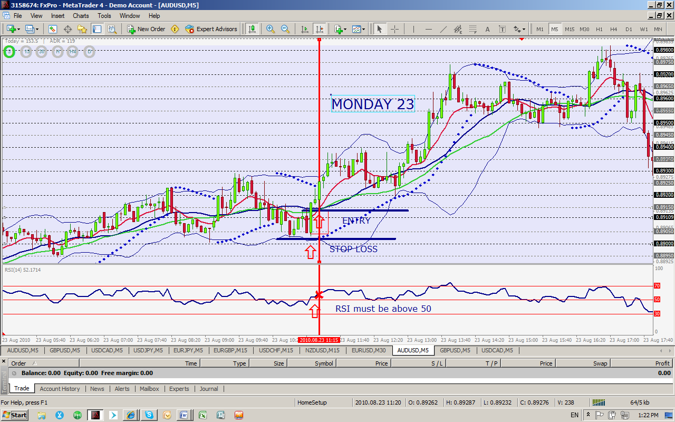
Short Trades will be taken ONLY if following conditions are met:

Price opens below 20 SMA where 9 EMA will act as a support line in case price retraced back.
RSI is clearly below 50 levels and heading down.
MACD same direction and below the 0 line.
Stochastic also down.

Entry is made when price is trading below the 9 EMA with RSI clearly in region below 50 levels. /In some cases You may notice retracement of price on the 9 EMA acting as a support. Possible re-entry if RSI still below 50 level and pointing down/.

SL /stop loss/ on HH / highest high / level: +1 pips.

Please check the Screen Shots: at least 2 entries every day with 10 pips and above!

