Using GET’s Original setting

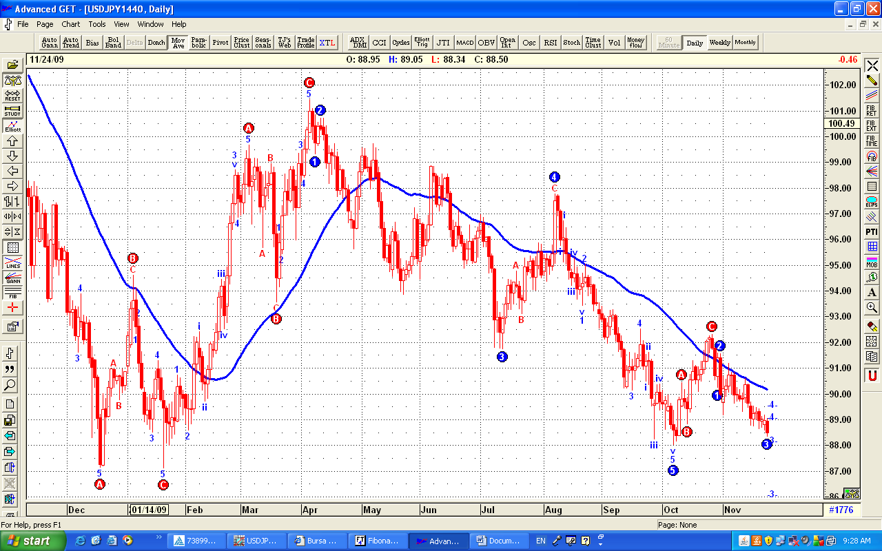

It is Wave 3 DOWN

Using GET’s Long Term alternate Count:

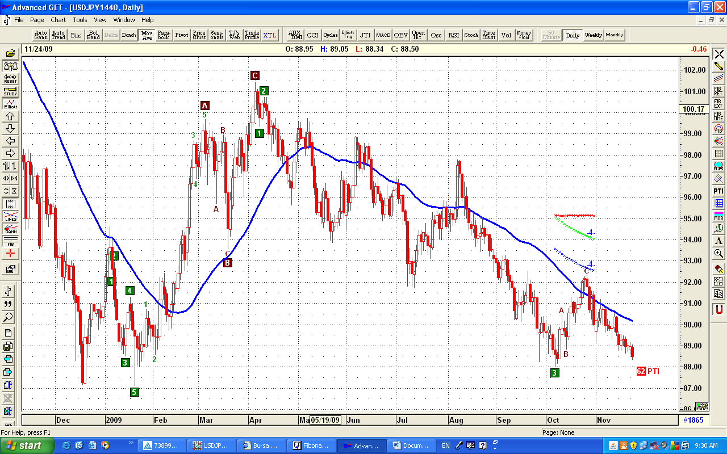

Also Wave 3 Down

Using GET’s Short Term Alternate Count:

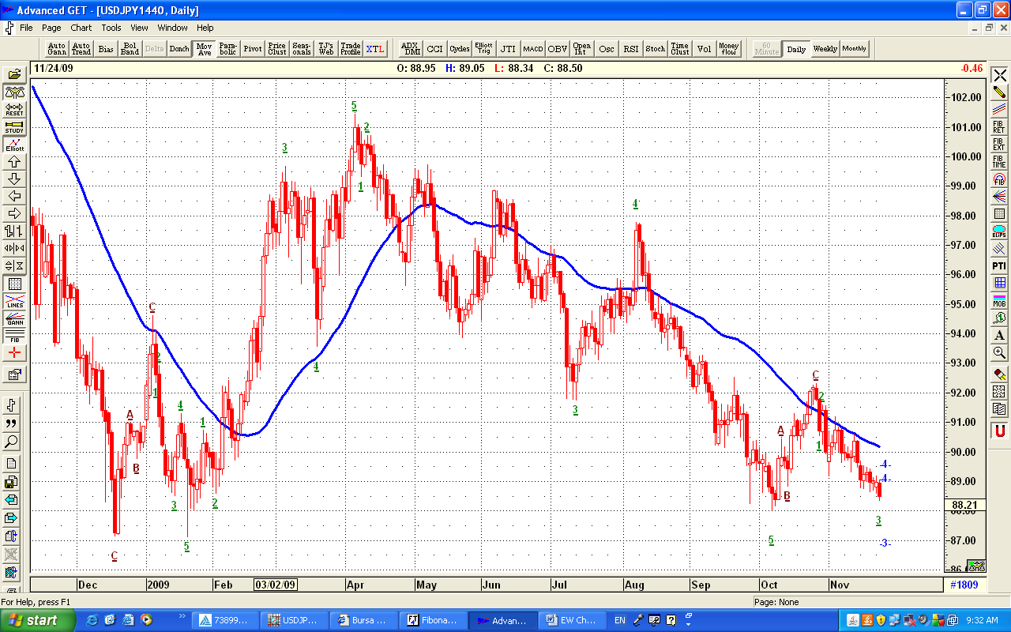

Also Wave 3 Down

And using GET’s Aggressive Alternate Count:

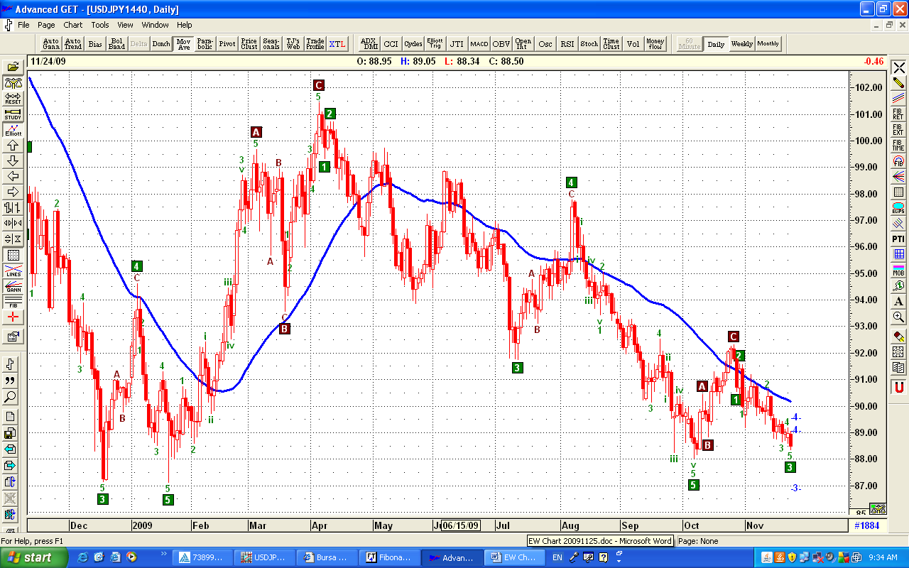

Also Wave 3 Down

