EA Requirements

The EA has to be able to do the following:

- Read the .csv file and take action based on the information in the file.
  - Each new signal will be on a new line in the .csv. So the EA needs to be able to know which lines are new lines and which ones it has already taken action on. We also need to be able to “clear” the .csv file once all positions are closed and have the EA not be “confused”.
  - Each signal pertaining to a specific trade has a unique signal ID. The EA needs to be able to associate the signal ID with a “trade ID” in the trading platform so that it will be sure to take action on the appropriate open position. (There may be multiple trades open at one time in a given currency pair)
- Send an email to a specified account any time an action is taken in the platform.
- We need a way to tie the email parsing program and the EA together. We don’t want the EA constantly polling the .csv file and looking for updates because it will lock the file for editing when it is polling. This would mean that the parsing program wouldn’t be able to write to the .csv file when a new signal is received if the EA is polling at that moment in time. I believe a better way to do it would be to somehow have the parsing program notify the EA when it has written to the .csv file and at that time the EA will poll the file and execute any new lines that are in the file. The parsing program is written in VB6. I’m not sure how to tie the parser with the EA but if someone can let me know then I can get with my VB6 programmer and we can work it out.
- I’m not sure about this one yet, but I was thinking that the EA should be able to check the current price of a currency pair prior to entering into a position and make sure it’s close to the signaled price just in case the signal was delayed and there was significant price action since the signal was issued. I’ll need the input from someone else to be able to determine what adequate values would be. These values should also be easily adjustable by your average user so that it can be configured to a user’s unique specifications.

That’s it in a nutshell!

Now for an explanation of the format of the .csv file. Below is an example. The file is propagated from top to bottom so newer signals are at the bottom.

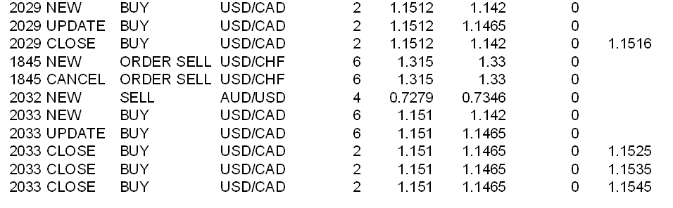
As you can see, there are 9 columns. Here is what they represent.

SignalID:TypeofSignal:Action:CurrencyPair:NumberofLots:Open:Stop:Limit:Close

SignalID: This is a unique ID assigned to the signal by the signal provider. All signals associated with a specific position have the same signal ID.

TypeofSignal: This will have a value of either New, Update, Close or Cancel. Cancel will only be sent in the event that there is an active Order Buy or Order Sell on the table and the signal provider cancels it.

Action: This will have a value of either Buy, Sell, Order Buy or Order Sell.
CurrencyPair: This will be the currency pair associated with the trade.

Number of Lots: The number of lots a user wishes to trade. This is controlled by the signal provider but can be adjusted to fit a user’s strategy by editing a multiplier in the signal parser. For example, if your signal provider trades up to 6 lots in a trade and you wish to do half then you can set your multiplier to 0.5 in the parsing program and it will enter ½ of the number of lots specified by your provider into the spreadsheet. So there is no logic on the EA’s part concerning this portion of the strategy. The EA is mostly mechanical and makes its decisions based purely on the .csv file.

Open: This is the open price of the position. 99% of the signals sent are market orders. If the Action of the signal is Order Buy or Order sell then it’ll be the order price.

Stop and limit: is there an explanation needed on these? These may be set in the first signal sent for a trade or may be sent in update signals. They may also be adjusted with update signals. Sometimes they may never be set at all!

Close: The only time this field will be populated is when the signal provider has closed out a trade at market value.

Now let’s look at the example log and walk through the trades to see how the trades progress.

The first line is the very first signal that we received since we last cleared our log (.csv) file. It begins the trade with signal ID 2029. As you can see, we’re Buying USD/CAD 2 lots at market value and setting our stop with the first signal. The 2nd signal with ID 2029 is only adjusting the stop. The 3rd signal with ID 2029 is closing out both lots at market value.

The signals associated with signal 1845 were putting in an order to sell USD/CHF 6 lots at a value of 1.3150 and setting a stop of 1.3300 in case the order is actually executed. It just so happens that this order was cancelled with the 2nd signal.

Signal # 2032 is selling AUD/USD 4 lots at 0.7279 and setting the stop at 0.7346. This is a market order to enter into the position. Since there are no other signals with an ID of 2032 then we can tell that there have been no further updates and the position is still open.

Signal 2033 starts out like the others, but I threw this one in to show how they can sometimes exit the trade differently. As you can see, this one is exited in steps… 2 lots at a time at different levels. We initially bought 6 lots in this trade but we exited by selling them off in 3 different signals with 2 lots in each signal. See why it’s important to tie the provider’s signal ID with a trade ID in the platform?

Here is a little logic for the EA. The EA only has to take into account certain columns for certain types of signals. This may not be needed, but I’m including it just in case. This may or may not make things easier and more “clean” since the signal ID is associated with the trade ID.

If the signal type is new, then all columns should be taken into account except for the “close” column.

If the signal type is update then it needs to take into account the following columns:

SignalID:TypeofSignal:Stop:Limit

If the signal type is close then it needs to take into account the following columns:

SignalID:TypeofSignal:NumberofLots:Close
Number of lots are still needed in case there is a multiple exit strategy on the trade.

If the signal type is cancel then it needs to take into account the following columns:

SignalID:TypeofSignal

Here are some “what if’s”. What if your automated solution is at home and you’re monitoring the trading remotely. You get an SMS on your phone for a new signal but you never get a notification on your phone that the trade was executed. You check and your home internet connection is down so you make the trade manually. Next thing you know your home internet connection comes back up and signals start coming into your .csv file. What happens? Just something to consider!

