The Bearish 5-0 Pattern
The Bearish 5-0 starts at the 0 point, representing the low of an extended rally up to the initial point of the pattern at X. The initial point X sets up the failed break out area, where the rally from the A point to the B peak, nominally takes out the prior high at X. Again, this is the failed wave 3 or wave 5 – in Elliot Wave terms – that establishes the rest of the structure.

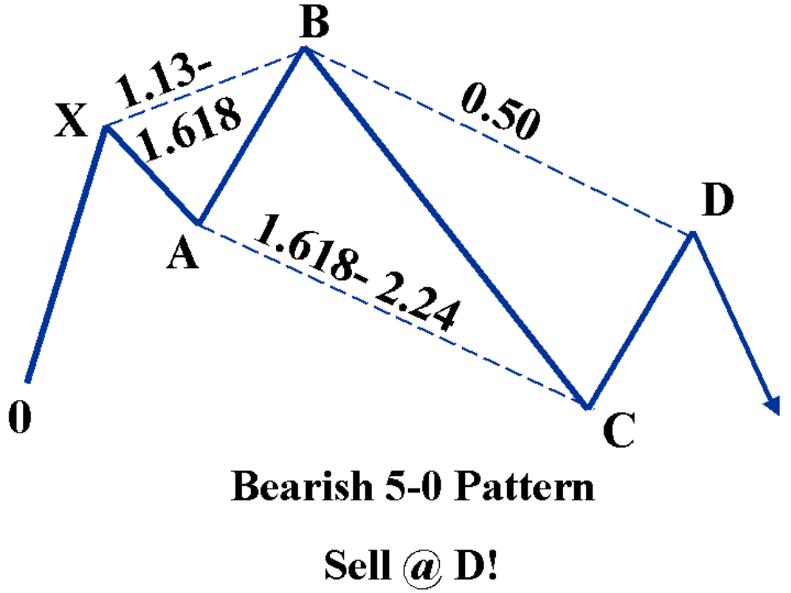

Remember, this X, A extension must be at least a 1.13 but not greater than a 1.618. After that impulsive failed wave is established, the BC leg declines to at least a 1.618 extension of the AB length but it does not exceed 2.24. Again, this tight range of 1.618-2.24 is a defining element of the structure. If the 1.618 limit is not reached, the structure is not a valid 5-0. After the BC leg has reversed from that zone, the bearish 50% retracement is measured from the B point to the C point. In addition, the Bearish Reciprocal AB=CD is projected from the C point (an equivalent length of the AB leg) to compliment the Potential Reversal Zone (PRZ).

AMEX Oil Index
($XOI): Daily
This is a fantastic example of a Bearish 5-0 structure that possessed the ideal Fibonacci alignment to validate the pattern. After a long rally, the index made an initial peak at the X point, pulled back to point A and reversed sharply at the B point, establishing the failed wave or triangle of the 5-0 structure.

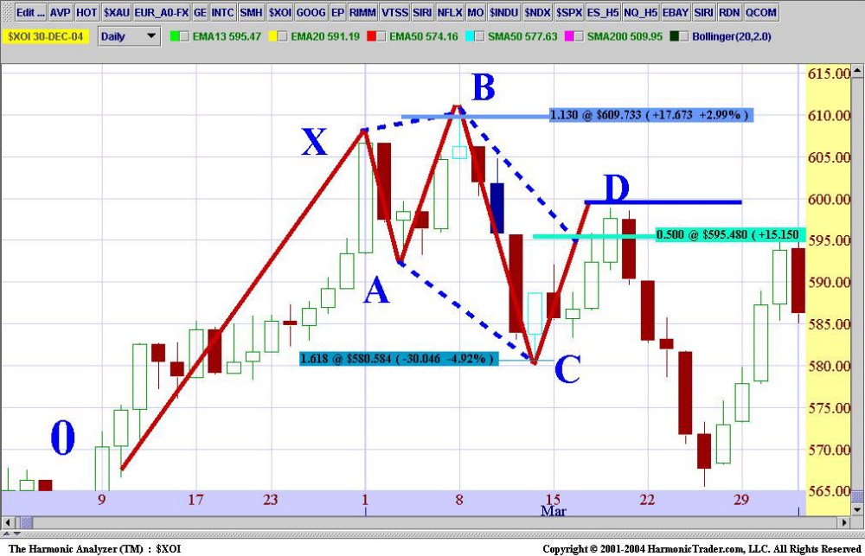

The following chart of the price action in the Potential Reversal Zone (PRZ) clearly shows the sharp reversal following the test of the 50% level. The Bearish Reciprocal AB=CD complimented the 50% retracement and defined a tight range just under the 600 level. The day after the $XOI tested 50% level, it started to reverse.

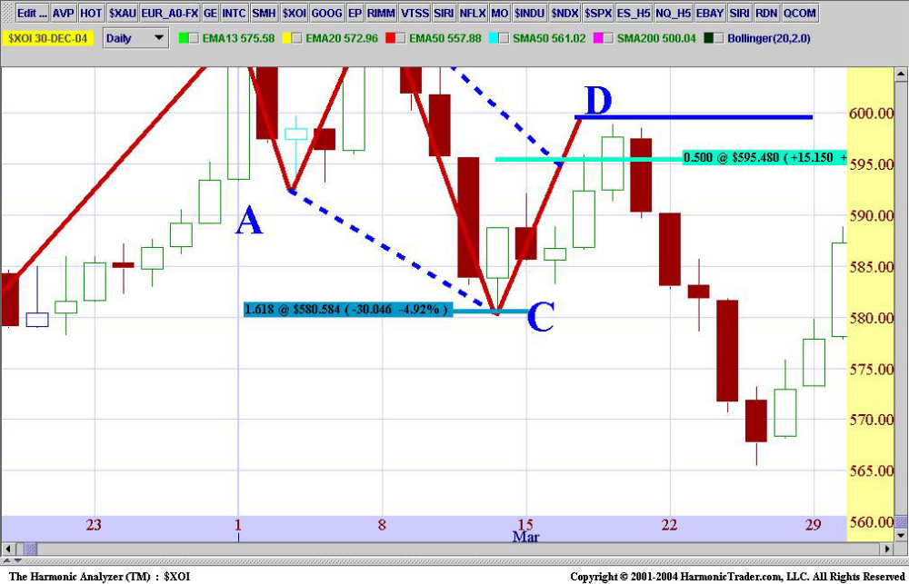

It is important to point out the C point on this chart. The mandatory 1.618 requirement was met in this case but it was close. If the C point did not test the 1.618 or fell just shy, it would invalidate the structure. It is important to understand that there is no discretion outside the prescribed parameters for the 5-0 pattern. Although such strict application reduces the number of potential trading candidates, it serves to distinguish the best opportunities.

Standard and Poor’s 500 September 2004 Mini-Contract
(ES_U4): 5-Minute
This 5-minute chart in the ES shows another ideal intraday structure with a perfect 50% retracement, calculated at 1096 with the completion of the Reciprocal Bearish AB=CD slightly below this level.

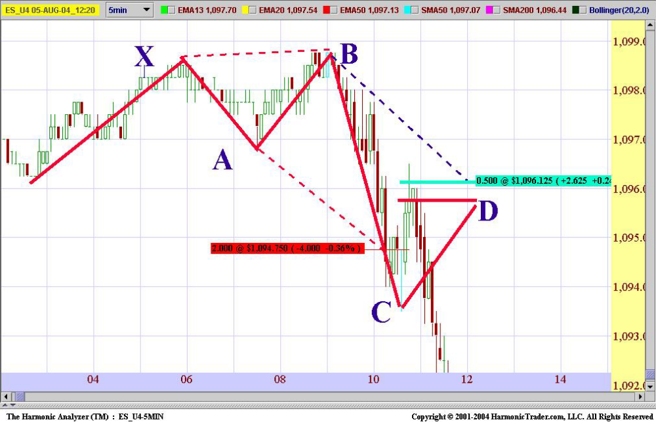

The following chart of the price action in the Potential Reversal Zone (PRZ) clearly shows the sharp reversal following the entire test of the 5-0 resistance. The Bearish Reciprocal AB=CD complimented the 50% retracement and defined a tight intraday range at 1096. The ES rolled over sharply within a few price bars of the resistance.

This Bearish 5-0 possessed an ideal reversal and downside continuation, which is a common trait of valid structures. The best trading opportunities usually provide quick indication of the validity of the reversal.

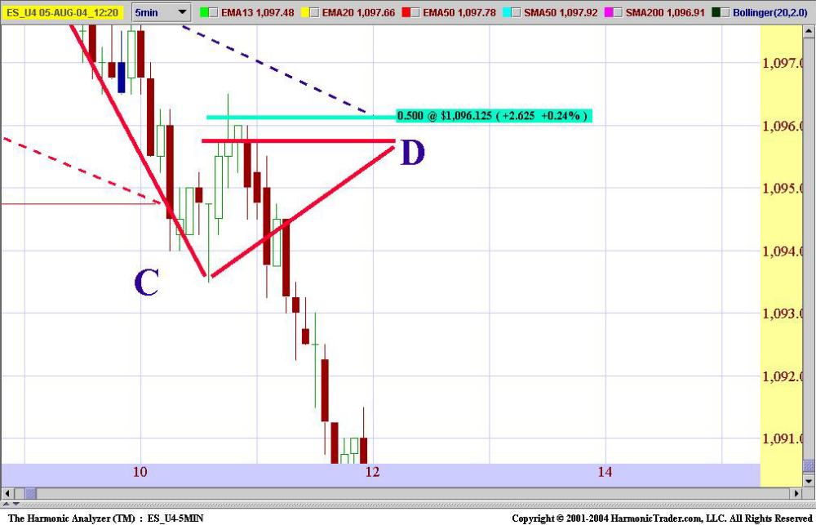

In this case, the ES stalled exactly at the harmonic numbers and rolled over shortly thereafter. Whether it’s a 1-minute, 5-minute, 60-minute, daily or weekly chart, the principles remain the same, as clear opportunities like these will present themselves on all time frames.

Conclusion
The 5-0 pattern represents the next step in the evolution of Harmonic Trading. Although the 5-0 possesses many similarities as the other harmonic patterns, there are several distinguishing traits that make it a unique structure. It is an effective pattern but requires a strict application of the rules.
I have outlined the basic identification parameters in this article. In my next book, Harmonic Trading of the Financial Markets: Volume Two, I will expand on this material, covering detailed execution and trade management strategies, specifically designed for the 5-0 pattern. Although this is a new discovery, the 5-0 pattern is an effective weapon within the Harmonic Trading arsenal.

The 5-0 Pattern By Scott M. Carney Copyright HarmonicTrader.com, L.L.C. 2005 All Rights Reserved!

