System ATCF

General information.

This commercial system or method of the analysis of markets, more precisely is called " the adaptive method of movement after the tendency and market of [tsiklami]". This is the system, created on the basis of the contemporary technologies of the spectral analysis of markets, which consists of the necessary collection of the indicators, synthesized with the aid of the digital filters, necessary for the professional analysis of market. System is the set of indicators for Metatrader.[Oni] very simply they are incorporated in the commercial terminal it is joined to any [chartam] by the pressure only of one [knopochki]. The set of indicators is shown below in the figure. Thus: FATL (Fast Of adaptive Of trend Of line) “rapid” adaptive line of trend is obtained with the use of the digital the filter of low frequency. (cream line on the price graph) SATL (Slow Of adaptive Of trend Of line) “slow” adaptive line of trend is obtained with the aid of the digital filter of the low frequency of another order. (blue line on the price graph) Analogs FATL and SATL among the widely known technical instruments there does not exist.
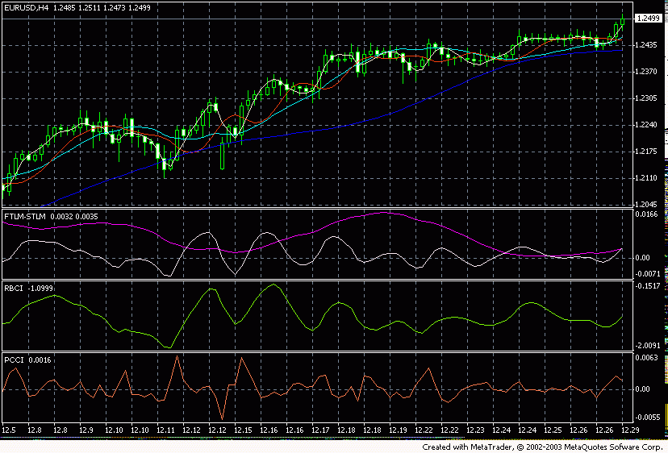
Ris].1
RFTL (Reference Of fast Of trend Of line) the reference “rapid” line of trend. (red line)
RSTL (Reference Of slow Of trend Of line) the reference “slow” line of trend. (dark-blue line)
RBCI (Range Of bound Of channel Of index) the limited on the strip index of channel calculated with the aid of the band-pass filter. (second indicator from below light-green line).
FTLM (Fast Of trend Of line Of momentum) and
STLM (Slow Of trend Of line Of momentum) show a rate of change (drop or increase) IN FATL and SATL. (uppermost indicator in the window, white and violet lines).
PCCI (Perfect Of commodity Of channel Of index) the perfect index of commodity channel. (lowest indicator orange line)).

And so - the basic principles, which one should observe with the development of concrete commercial algorithm, that follow: - to deal only in the direction of the ruling tendency, whose direction is determined “slow” adaptive line of trend SATL; - to consider the dynamic characteristics “rapid” and “slow” trend, been indicators FTLM and STLM; - to use information about range of values in what (neutral, outbid, resold, local maximum or the local minimum) is located the sum of the prevailing market cycles (index RBCI). - to consider the signals of oscillators second in cases when trend indicators testify about the presence of the clearly expressed bear or bull tendency; - to consider the signals of oscillators basic in cases when trend indicators signal about the absence of the clearly expressed tendency; to use the flexible system of shielding foot- orders, based on the indications of indices RBCI, PCCI and the values of [volatilnosti] “rapid” market fluctuations. The fundamental rules of the interpretation of the above-indicated tools are the following: - the growing line SATL testifies about the bull trend on the market.

In figure 2 these are sections 1,6.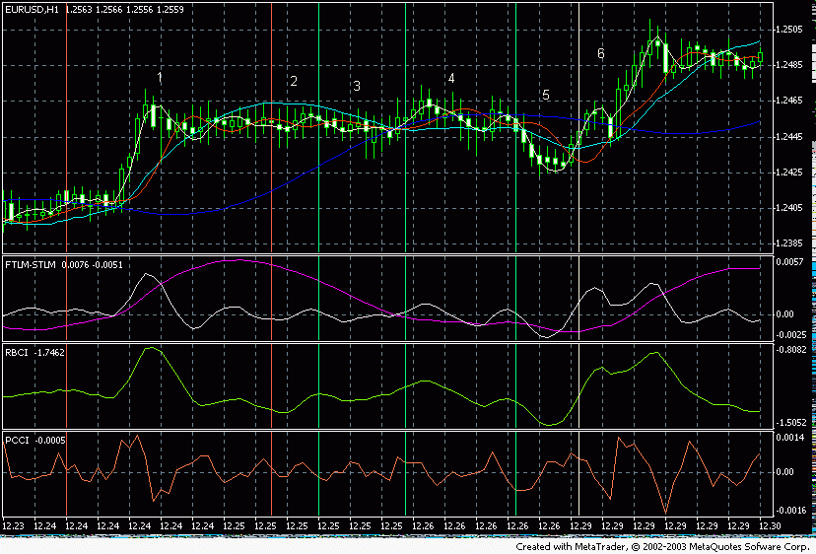

[Ris].2 - the turn-off point of bear trend is considered the point of the local minimum SATL. (figure 3)
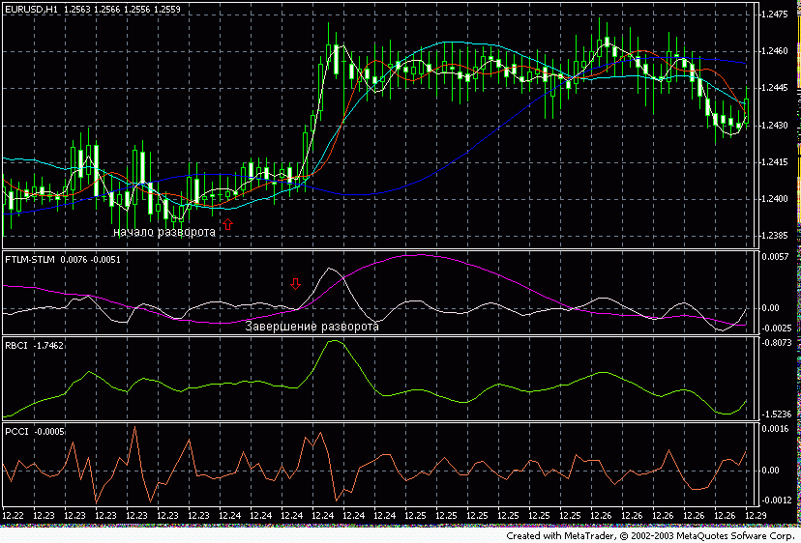

[Ris].3 - the point of the completion of the turn of bear trend is considered the point, at which the sign STLM was replaced from minus to plus. (figure 3) - the falling line SATL testifies about the bear trend on the market. (section 3, 5 IN fig 2) - the turn-off point of bull trend is considered the point of the local maximum

Pic 4
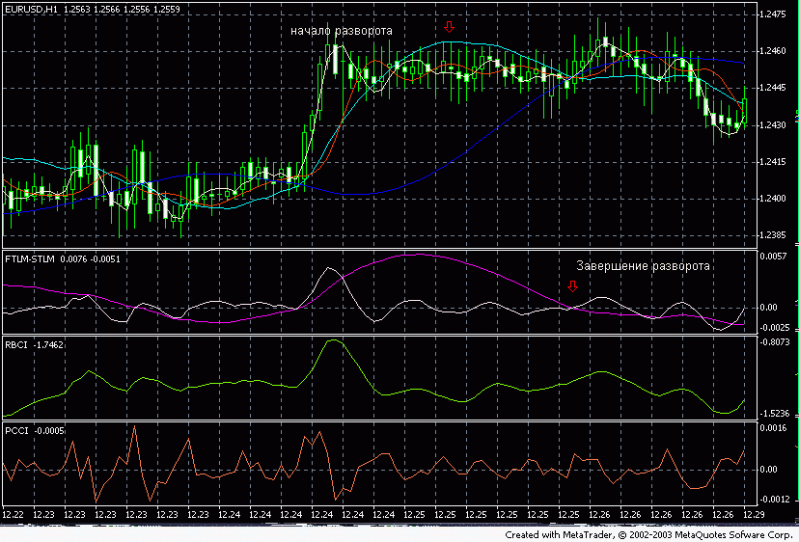

Fig 4 - the point of the completion of the turn of bull trend is considered the point, at which the sign STLM was replaced from plus to minus. ([Ris].4) - close to the horizontal form SATL testifies about the neutral tendency. (section 2, 4 IN fig 2) Interpretation STLM requires special attention. - positive value STLM testifies about the bull trend, and negative about the bear tendency. - - STLM is the anticipating indicator. (to [ris].5 entire visible section STLM it did not descend below zero line - it means to face the ascending trend

Interpretation STLM requires special attention. - positive value STLM testifies about the bull trend, and negative about the bear tendency. - - STLM is the anticipating indicator. (to [ris].5 entire visible section STLM it did not descend below zero line - it means to face the ascending trend.) Fig 4 of the of point of of the of completion of of the of turn of of bull of trend is of considered of the of point, at of which of the of sign STLM of was of replaced of from of plus to of minus. ([Ris] .4) - close to of the of horizontal of form SATL of testifies of about of the of neutral of tendency. (section 2, 4 IN of fig 2) Of interpretation STLM of requires of special of attention. - positive of value STLM of testifies of about of the of bull of trend, and negative of about of the of bear of tendency. - - STLM is of the of anticipating of indicator. (to [ris] .5 entire of visible of section STLM it of did of not of descend of below of zero of line - it means to of face of the of ascending of trend

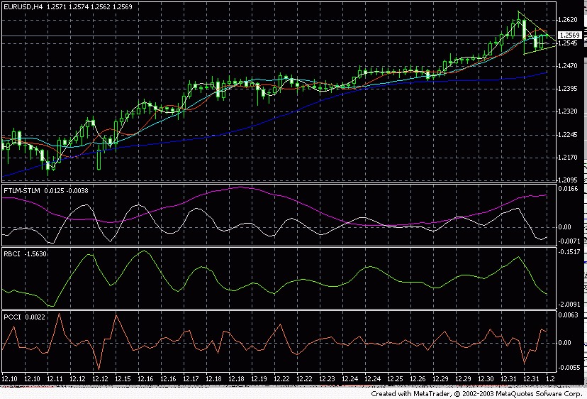
[Ris].5 - the local minimum STLM (red vertical line) always precedes the local minimum SATL (yellow vertical line). This must be considered with making of commercial decisions. To [ris].6 evidently precisely this situation, and the conclusion, which necessary to make is such: “Not to open position with the turn STLM. To wait for confirmation SATL and only in this case to go into the market
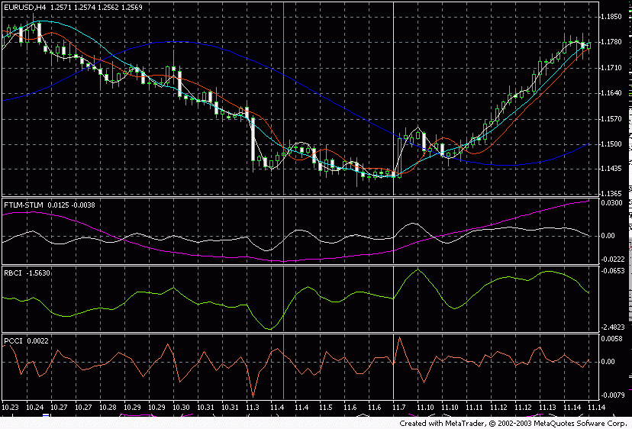
Ris].6 - local maximum STLM always precedes local maximum SATL. You will look, how we would be mistaken, if they would be opened downward with the achievement of maximum STLM? [Ris].7
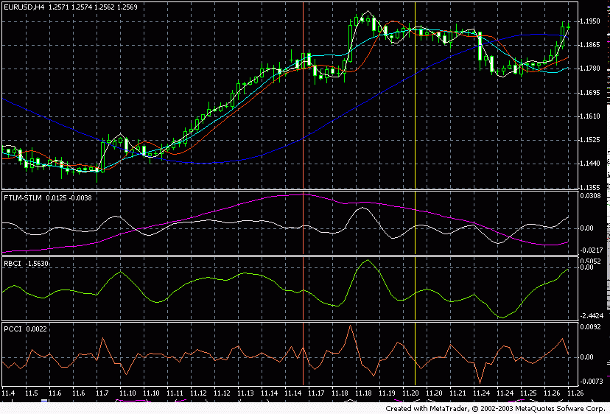
Ris].7 - reaching STLM of its extreme points is the necessary, but insufficient condition for reaching by the curve SATL of the apex or bottom. - growing STLM with growing SATL testifies about the acceleration of bull trend. (this section 1 to [ris].8)
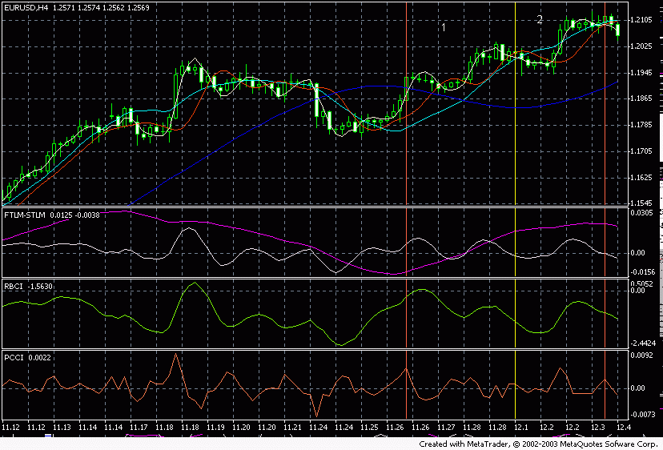
[Ris].8 - horizontal and positive STLM with growing SATL testifies about the steady bull trend. (this section 2 to [ris].8) - the greater the absolute value STLM, the greater the potential has bull trend. - falling STLM with falling SATL testifies about the acceleration of bear trend. - horizontal and negative STLM with falling SATL testifies about the steady bear trend. - the greater in this case the absolute value STLM, the greater the potential has bear trend. - the growing “rapid” line of trend FATL with the growing “slow” line of trend SATL testifies about the strong bull trend on the market. To [ris].9 this section of 2.[Kak] is evident from the figure the safest points for the entrance into the market - this maximums FTLM on falling STLM
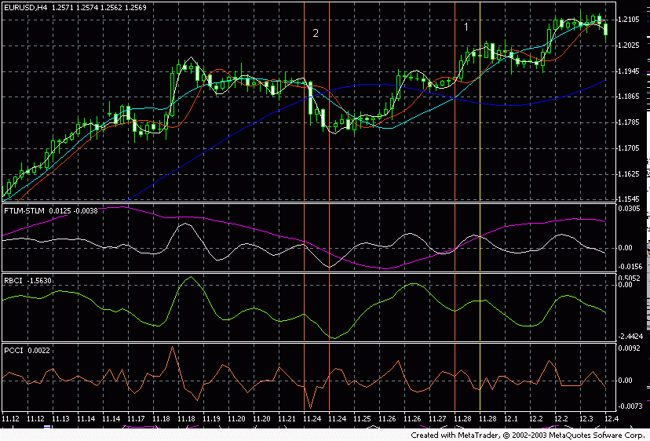
Ris].9 - the falling “rapid” line FATL with the falling “slow” line SATL testifies about the strong bear trend on the market. - the growing line FATL with the falling line SATL testifies either about the bull correction with the bear trend or about the consolidation. And natural to play in the direction FATL cannot. This the same, what to swim against the wave…
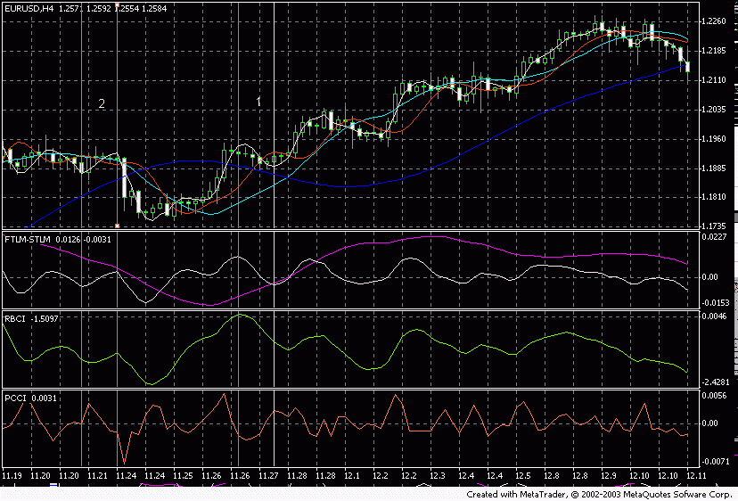
Ris].10 This is section 2 to [ris].10 - the falling line FATL with the growing line SATL testifies either about the bear correction with the bull trend or about the consolidation. This is section 1 to [ris].10 - beginning or renewal of motion in one direction of lines FATL and SATL signal either about the turn of tendency or about the completion of correction and the renewal of the motion of prices in the direction SATL. The use only of this rule improves your trade by an order. To [ris].11 are given all points of entry and output. If profit is obtained - we see the appropriate mark of the large finger of that expanded upward. If transaction unsuccessful - then thumb is expanded downward. But if we remove entire trade downward, as t to price was not passed turn blue below [lini] RSTL - [t].[e]. on the market acts the long-run trend upward…
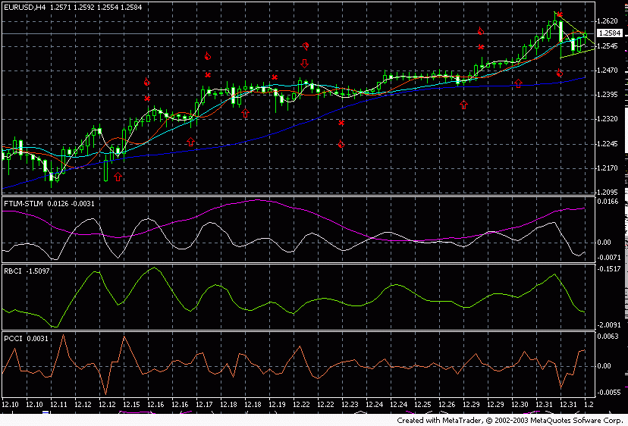
Ris].11 The general rules of analysis are such. Now based on the example of graphs EUR/USD let us try to analyze market. Let us take weekly graph in fig 12
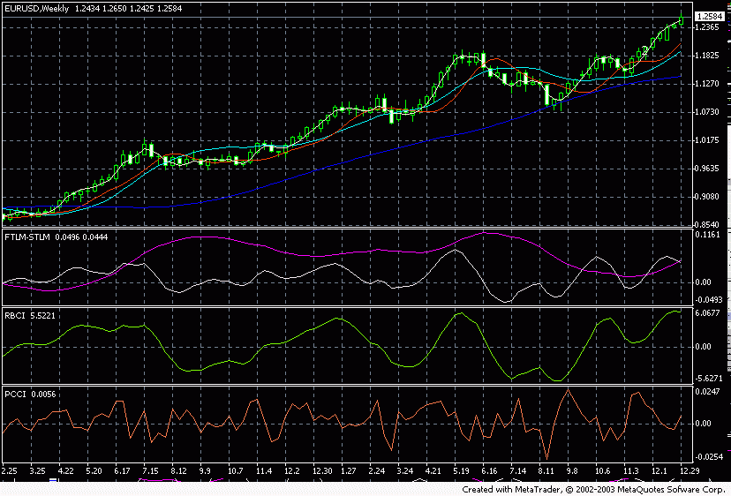
Ris].12 RSTL, RFTL, SATL, FATL are directed upward. This is the very strong index of the ascending trend. But price already sufficiently far left upward from turn blue line RSTL. Recoil is possible downward. STLM is also directed upward, moreover it was developed even without having reached the zero line, which also confirms strong trend upward. But reaching maximum values RBCI underneath turn BY FTLM speaks about the ripened correction of trend. Conclusion: the ascending trend acts. But mto occupy positions upward of [arkhi] is dangerous, indeed RBCI and FTLM show the beginning of possible correction. T to play against the trend is very dangerous - version one. To wait. To wait the minimum FTLM and with growing STLM to only enter into market upward. Thus far out of the market. But out of the market only on the weekly graph. In the smaller time intervals, possibly, very briefly to play into both sides. (STLM, FTLM they have different direction). We pass to the day graphs of [ris].13
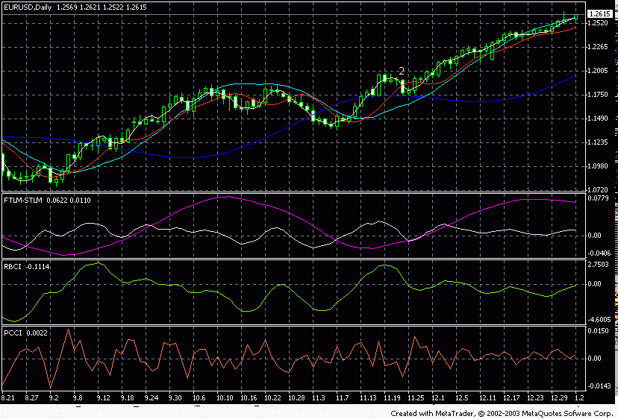
[ris].13. We see that STLM already showed its maximum and was developed downward, but SATL is still thus far directed upward. Therefore cannot be played downward thus far. But also upward to be opened is already very dangerous. Necessary to wait when SATL will show its maximum, also, with the turn FTLM and RBCI is downward possible to occupy a position downward with the stop of higher than the last maximum. FTLM already shows as if maximum, but BY RBCI it is directed upward - it means we wait. The apex of market - this is the most tempting point for the entry, but there are here many frauds. Therefore we enter into market only with the turn of all indicators downward. We pass to the graph 4 hours to [ris].14
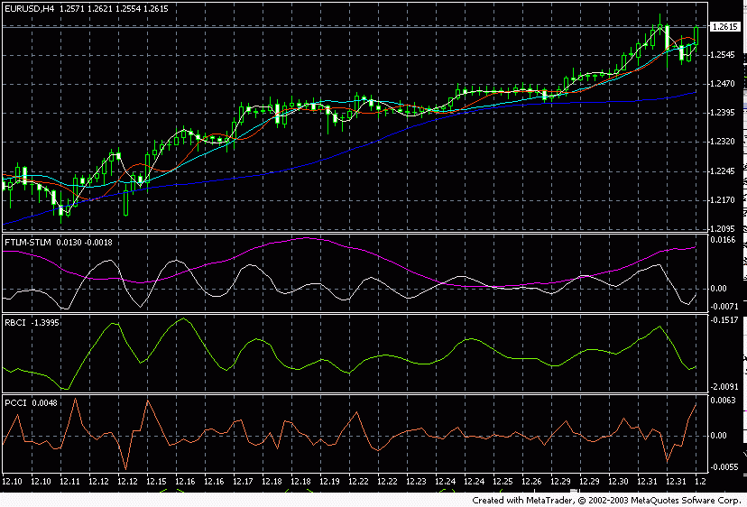
Ris].14. We see that STLM is almost horizontal, what makes possible for us to play into both sides with the achievement of maximums FTLM - downward, the minimums - upward. And so until SATL is developed downward. Then we play only downward with the achievement of maximums FTLM. Information: given graphs are undertaken 02.01.2004 in 12.00 msk. The unquestionable merit of this method in the fact that on one graph we see immediately two tendencies - acting super-long (RSTL), acting long (SATL) and immediate (FATL, FTLM). Which makes it possible to very clearly track all waves of the developing tendency, or presence in [Flete]. Let us now move on to the signals, which issues this system: Signals for the discovery of positions downward S:

S1- this reliable of [medvezhiy] signal on the peak of bull tendency. 1. The first bear correction of strong bull trend as a rule, precedes. 2. After the correction occurs bull motion but already on the falling indicator STLM. 3. Occurs rapprochement SATL and RSTL. 4. To sell with the underneath turn BY FTLM and RBCI. 5. Stop is higher than the last local maximum. This signal is shown to [ris].15.
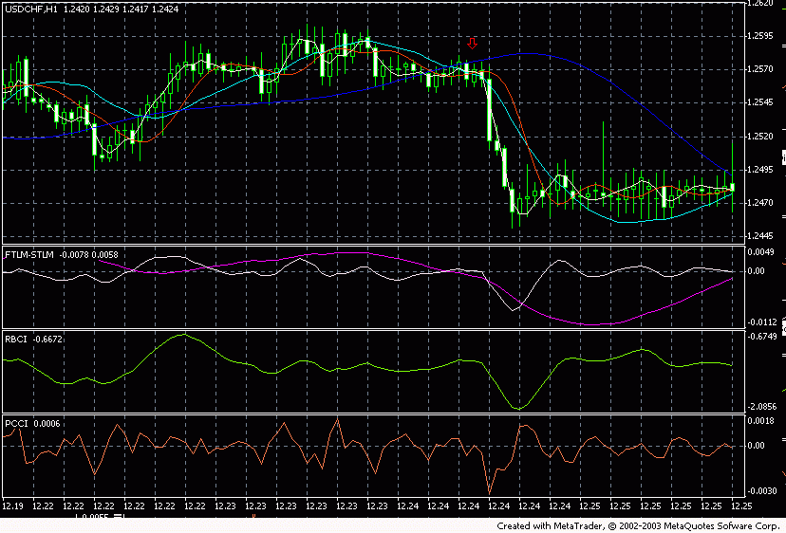

ris].15 S2A and this S2B- the typical signals of the continuation of bear tendency after the completion of bull correction. 1. Bear tendency has already been formed and was collected the force (it was already the intersection from top to bottom WITH SATL and RSTL). 2. Synchronization of the motion of indicators FATL, FTLM, RBCI at the moment of signal shaping. 3. It must fall, or move horizontally for S2A STLM. 4. It must grow for S2[V] STLM, which indicates the rapprochement SATL and RSTL.[Dlya] of this signal necessarily the absence of the resold market PCCI for sales. 5. The price of sale is selected above, or on the price of the discovery the following day. To [ris].16 - 3 signals S2A. To [ris].17 - signal S2B.
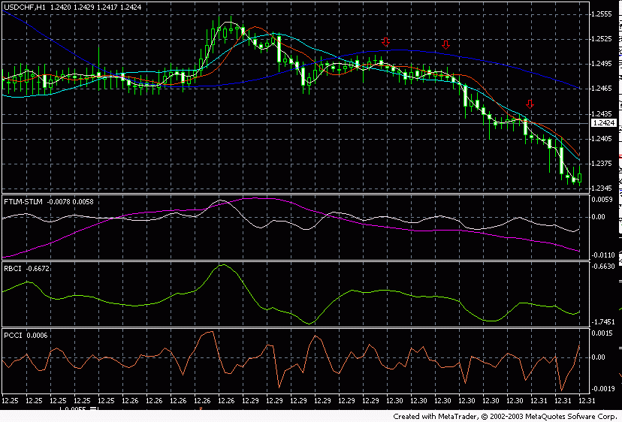
Рис.16.
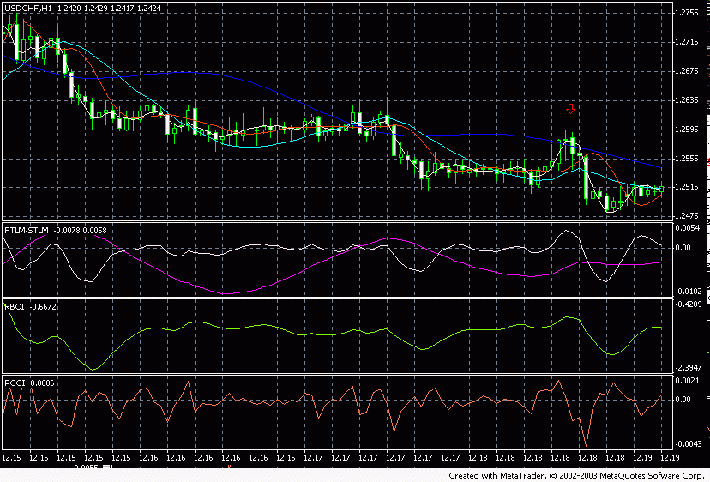
[Ris].17 the
S3- signal of [prodolzheni] of the trend 1. STLM are lower than zero. 2. FATL must be developed and is directed downward. 1. Signal is generated, when with the neutral or descending long-run trend (SATL it is horizontal or directed downward) OF PCCI is passed its local maximum to the zone of [perekuplennosti]. 2. The price of sale is selected above, or on the price of the discovery the following day. In fig 18 this signal is shown.
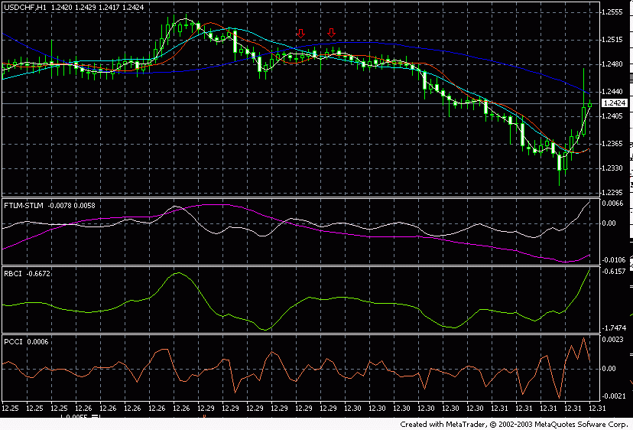
Ris].18

the S4- signal of dual divergence. 1. On the slow bull trend must ) 2. On the slow↑) with FATL (↓precede the differently directed motion RBCI ( )↑) with FTLM (↓bull trend must precede the differently directed motion RBCI ( 3. Trigger to the generation of commercial signal to sale is the minimum FTLM, when FATL and RBCI continue to move in the previous directions. 4. On the graphs this looks like a certain bend FTLM to the side FATL (upward). This occurs with the values FTLM of close to zero and during the motion of price upward. This moment is optimum for the discovery downward. This is the outstanding anticipating signal… 5. The price of sale is selected above, or on the price of the discovery the following day. [Ris].19.
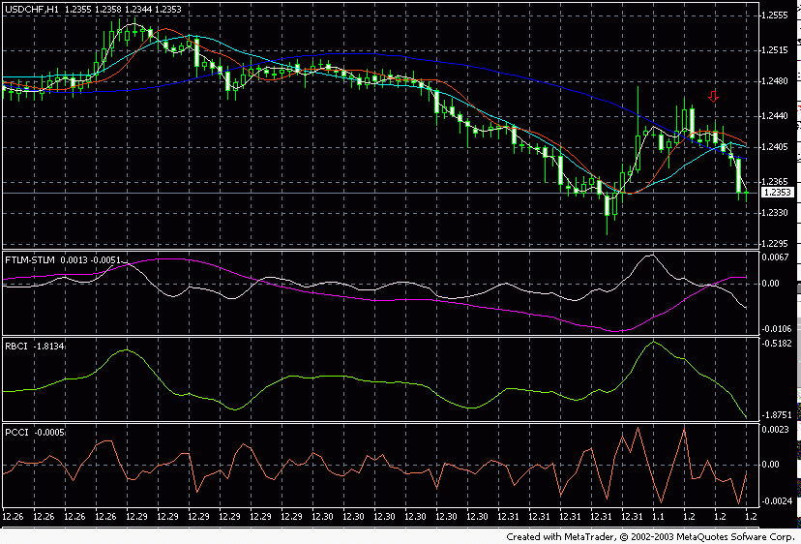
[Ris].19
S5- the signal of the continuation of tendency. 1. SATL - downward (bear long-run trend) (it was already the intersection from top to bottom WITH SATL and RSTL) 2. RBCI and PCCI in the outbid state. 3. Such signals frequently come in the completing phase of the basic descending tendency, when prices sharply take off upward, but under the action of basic tendency they then go downward. 4. The price of sale is selected above, or on the price of closing the day of obtaining [signala].[Ris].20
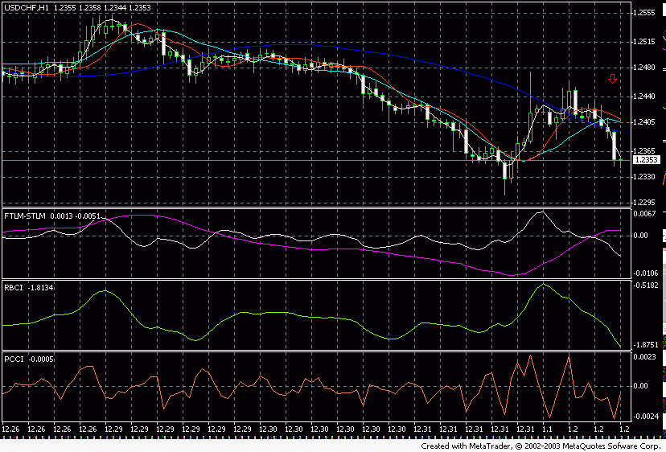
S6- the signal of the continuation of tendency. 1. SATL - already falls 2. STLM - is still higher than zero. 3. PCCI are higher than 0.01, which indicates [perekuplennost] of market. 4. This signal appears in the initial phase of bear tendency. 5. The price of sale is selected above, or on the price of closing the day of obtaining [signala].[Ris].21
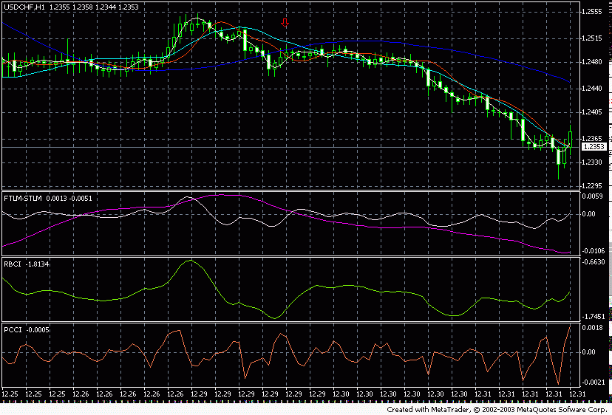
[Ris].21 the S7- powerful [razvorotnyy] signal 1. It appears by the test FATL SATL from top to bottom at the bull trend. 2. Further must pass the first technical correction of the descending trend upward. 3. We sell at the maximum FATL. 4. The price of sale is selected above, or on the price of the discovery the following day. [Ris].22
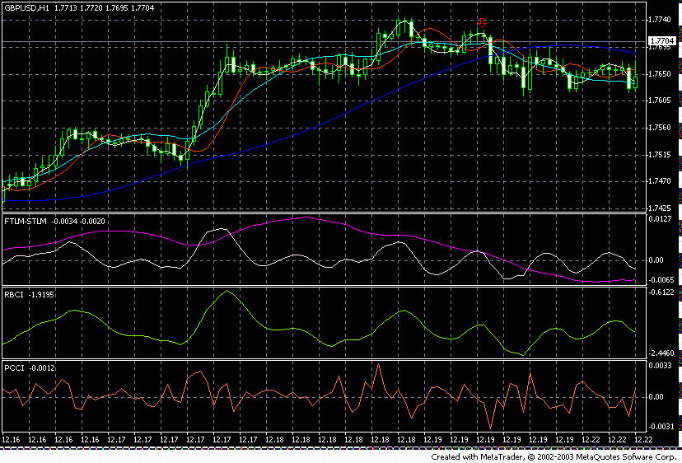
[Ris].22

[Ris].22 the S8- signal of acceleration. 1. Simultaneous breakdown from top to bottom OF FATL of slow SATL and rapid RFTL. 2. The price of sale is selected above, or on the price of the discovery the following day. [Ris].23
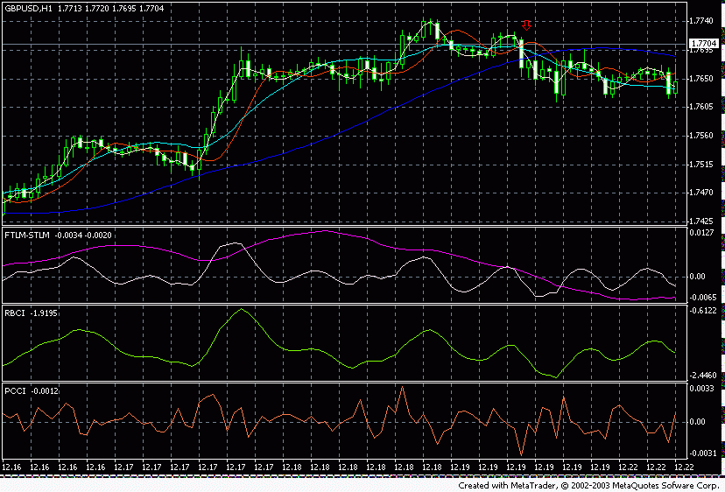
Signals for the discovery of positions upward

L: L1- this is reliable bull signal on the peak of [medvezhey] tendency. 1. The first bull correction of strong bear trend as a rule, precedes. 2. After the correction occurs bear motion but already on the growing indicator STLM. 3. Also occurs rapprochement SATL and RSTL. 4. To buy with the turn upward BY FTLM and RBCI. 5. Stop is lower than the local last maximum. This signal is shown to [ris].24.
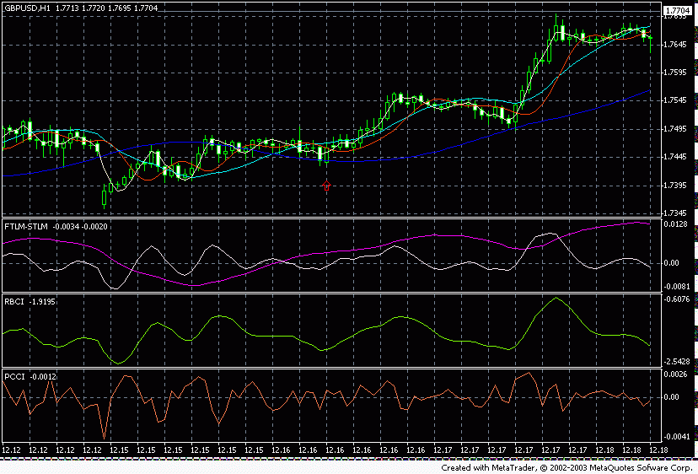
Pic 24

L2A and this L2B- the typical signals of the continuation of bull tendency after the completion of bear correction. 1. Bull tendency has already been formed and was collected the force (it was already the intersection from bottom to top WITH SATL and RSTL) 1. Synchronization of the motion of indicators FATL, FTLM, RBCI 2. It must grow, or move horizontally for L2A STLM. 3. It must fall for L2[V] STLM, which indicates the rapprochement SATL and RSTL.[Dlya] of this signal necessarily the absence of [perekuplennosti] of market RBCI for the purchases. 4. The price of purchase is selected below, or on the price of the discovery the following day. In [ris].25 are represented both these of signal.
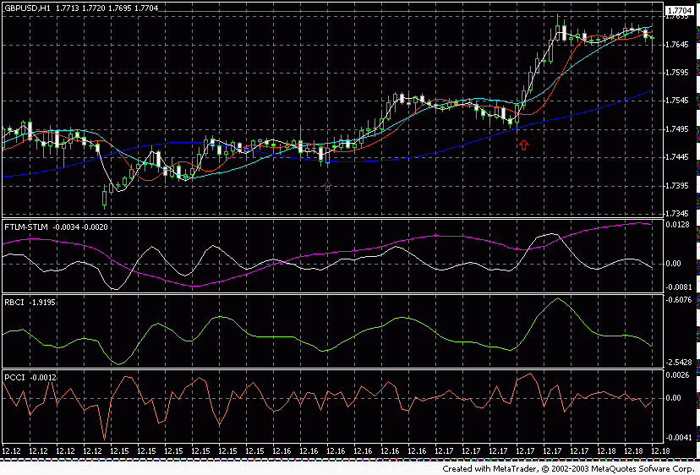
the L3- signal of the continuation of the trend 1. STLM - are higher than zero. 2. FATL must be developed and is directed upward. 3. Signal is generated when with the neutral or ascending long-run trend (SATL it is horizontal or directed upward) OF PCCI it passes its local minimum to the zone of [pereprodannosti]. 4. The price of purchase is selected below, or on the price of the discovery the following day. [Ris].26
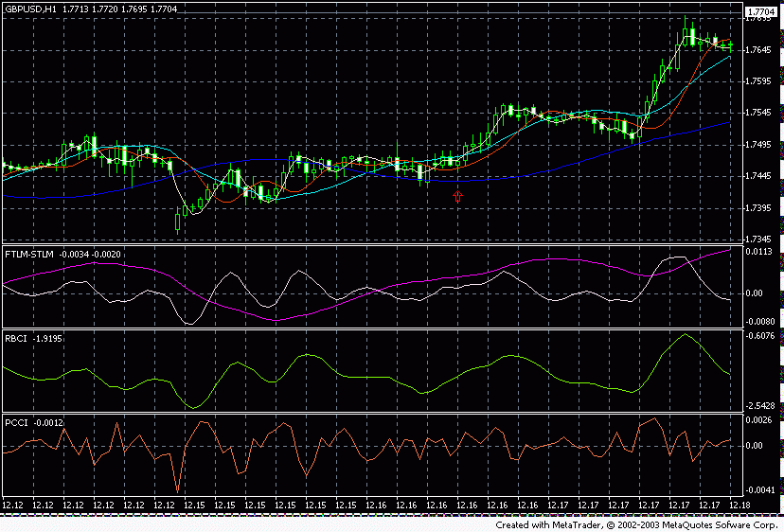
the L4- signal of dual divergence. 1. On the slow bear trend must precede the ) 2. On the slow bull trend↓) with FATL (↑differently directed motion RBCI ( ) 3. Trigger↓) with FTLM (↑must precede the differently directed motion RBCI ( to the generation of commercial signal to the purchase is maximum FTLM, when FATL and RBCI continue to move in the previous directions. 4. On the graphs this looks like a certain bend FTLM to the side FATL (downward). This occurs with the values FTLM of close to zero and during the motion of price downward. This moment is optimum for the discovery upward. This is the outstanding anticipating signal… 5. The price of purchase is selected below, or on the price of the discovery the following day. [Ris].27
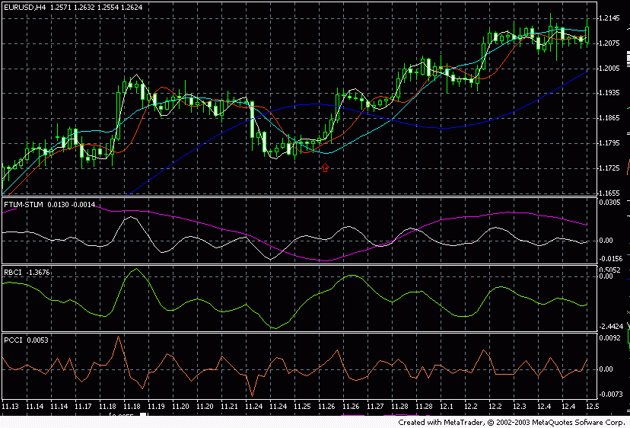
Pic 27

L5- the signal of the continuation of tendency. 1. SATL - upward (bull long-run trend) (it was already the intersection from bottom to top WITH SATL and RSTL) 2. RBCI and PCCI in the resold state. 3. Such signals frequently come in the completing phase of the basic ascending tendency, when prices sharply fall downward, but under the action of basic tendency they then go upward. 4. The price of purchase is selected below, or on the price of closing the day of the arrival of signal. [Ris].28
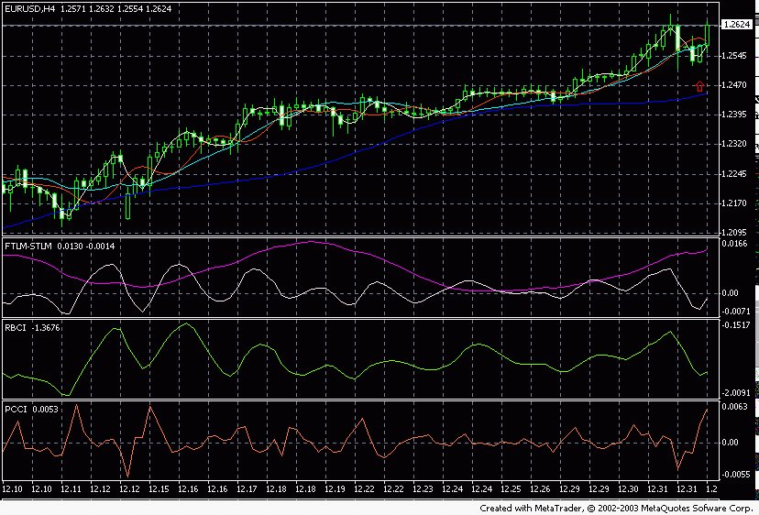
Pic 28

L6- the signal of the continuation of tendency. 1. SATL - already grows 2. STLM - is still lower than zero. 3. PCCI reaches values below - 0.01, which indicates the resold market. 4. This signal appears at the beginning of bull tendency. 5. The price of purchase is selected below, or on the price of closing the day of the arrival of signal. [Ris].29

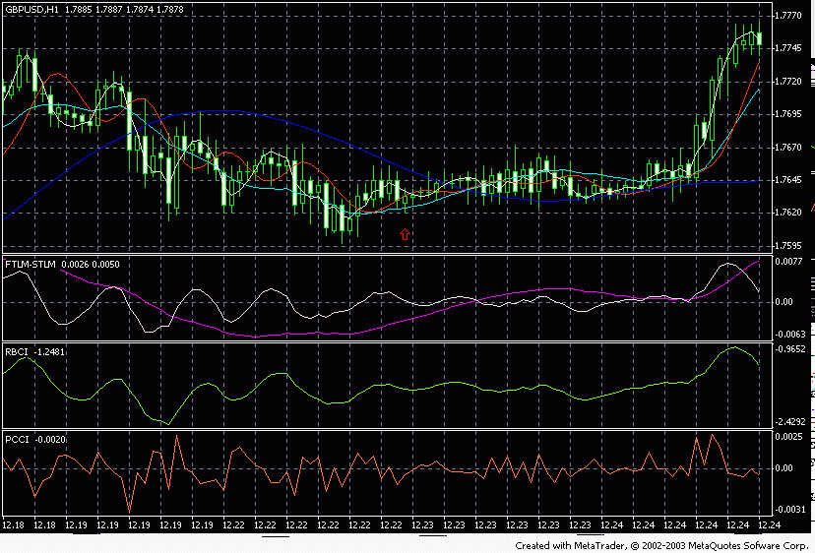
Pic 29

the L7- powerful [razvorotnyy] signal 1. It appears by the test FATL SATL from bottom to top at the bear trend. 2. Further must pass the first technical correction of the ascending new trend downward. 3. We buy on the minimum FATL. The price of purchase is selected below, or on the price of the discovery the following day. [Ris].30

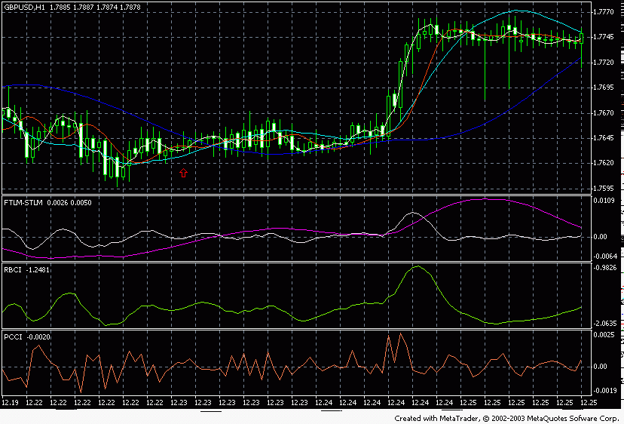
Pic 30

L8: the signal of acceleration. 1. Simultaneous breakdown from bottom to top OF FATL of slow SATL and rapid RFTL. 2. price of purchase is selected below, or on the price of the discovery the following day. [Ris].31
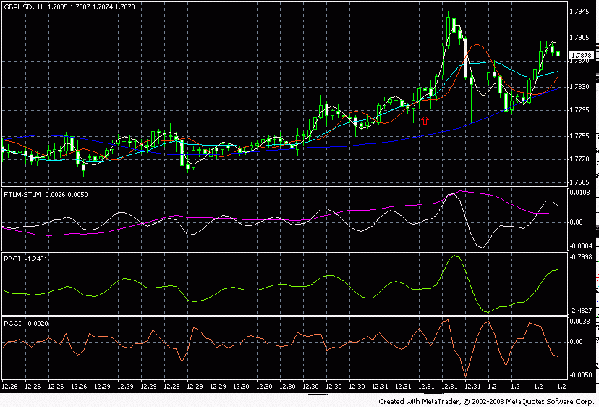Pic 31

Are such the basic signals, supplied with system ATCF. Now still several additions….

1. If SATL rises and BY STLM is positive (more than 0) - it means the long-run trend (quarterly) - positive. 2. If SATL is reduced and BY STLM is negative (lower than 0) - it means the long-run trend (quarterly) - negative. 3. If STLM opened zero level upward - this is strong bull signal. Until it descends below zero - bull trend remains. 4. If STLM opened zero level downward - this is strong bear signal. Until it rises above zero - bear trend remains. 5. If STLM approaches its maximum (minimum) value, means at this moment on the market it is present the maximum acceleration of trend and its retarding in the near future is expected. 6. We make basic money, when SATL passed its minimum and was developed upward, STLM - was also developed upward and RBCI passed its minimum and was developed upward (we work in the phase!!!). 7. WE MAKE basic money, when SATL passed its maximum and was developed downward, STLM - was also developed downward and RBCI passed its maximum and was developed downward (we work in the phase!!!). 8. Price range is determined on The rBCI.[Minimalnyy] - how much remained figures to 0. maximum - how much remained figures to the assumed maximum of this oscillator. 9. If RBCI rises and BY STLM is positive (more than 0) - it means trend- positive. 10. If RBCI is reduced and BY STLM is negative (lower than 0) - it means the long-run trend (quarterly) - negative. 11. RBCI - it is directed downward - goes bear trend. On it possible to forecast the range of the accessible prices. For example the maximum of indicator was. Indicator was developed downward. To 0 it remains 0, 5. it means prices still they will pass 5 figures. This is correct, if SATL is directed also downward. But if RBCI goes to the opposite side SATL - then this value it is necessary to divide the minimum 3 times (we work against the basic trend!). (range of reaching prices we look according to weekly graphs) 12. These indicators work on all currency pairs, but most precise on EUR/USD. Any temporary ranges yield to their analysis. But I recommend to play only on one currency pair. You must become accustomed to it. To understand it and not to change with it. It [otblagodarit]… Do not throw on the different pairs. This only pulverizes. Different currency pairs in different ways behave. It is necessary to select that loved for itself… And to play in the time intervals not below 4 hours. The time intervals, which lie below 4 hours give many spurious signals. 13. This picture can be observed near the significant levels of support. Short term trend FATL is directed upward. Near the minimum values it is below located BY RBCI. And PCCI also formed the minimum and it was directed upward - this is a good sign for the discovery upward - is expected good [volantilnost]. This indicates that this level of the support immediately of [preodolen], will not be, but there will be rebound from the support upward!!!! 14. This picture can be observed near the significant levels of resistance. Short term trend FATL is directed downward. It is above located BY RBCI and PCCI also was formed maximum it was directed downward near the maximum values - this is a good sign for the discovery downward - is expected good [volantilnost]. This indicates that this level of the resistance immediately of [preodolen] will not be, but there will be rebound from the support downward!!!! Is such classical approach in the analysis of market with the aid of the method ATCF (DIGITAL FILTRATION). Besides indicators themselves, into delivery set enters the digital generator of band-pass filters and the spectrum analyzer. With the aid of these tools you independently will be able to analyze the spectral composition of any market (spectrum analyzer), and to create the appropriate indicators, which consider the special features of this market (digital generator). The order of their use is described in the files of help, fastened to the program, and also on the site of the producer: http://finware.ru The order of the installation of indicators themselves is described in the archive in the file Of read Me. Let us examine joint operation ATCF ([STSF]) with the methods of classical proximate analysis. [STSF] and program EWA Let us look to the figure with the indicators [STsF].[Eto] day graph.
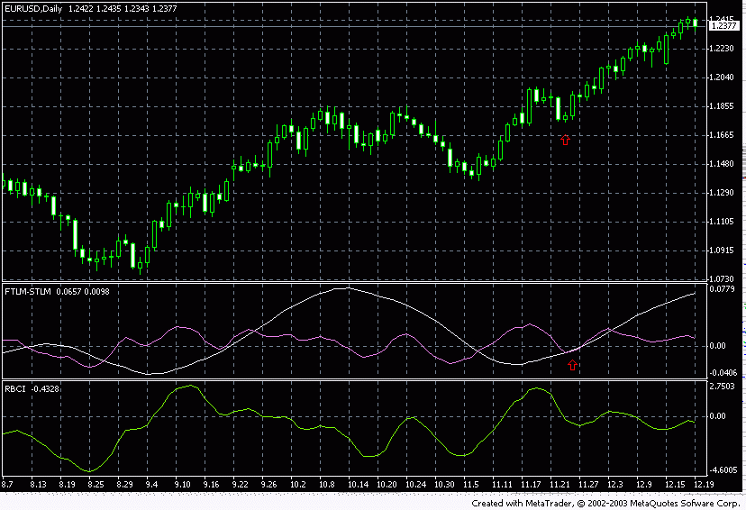
We see seemingly safe point for the entry upward. But so whether she is safe. To determine this will help the program of the analysis of the waves of Eliot EWA6. Here is its figure for the same graph, but I ster last given for EWA in order to model the moment of the break of tendency as on the previous graph (moment designated by red pointers).
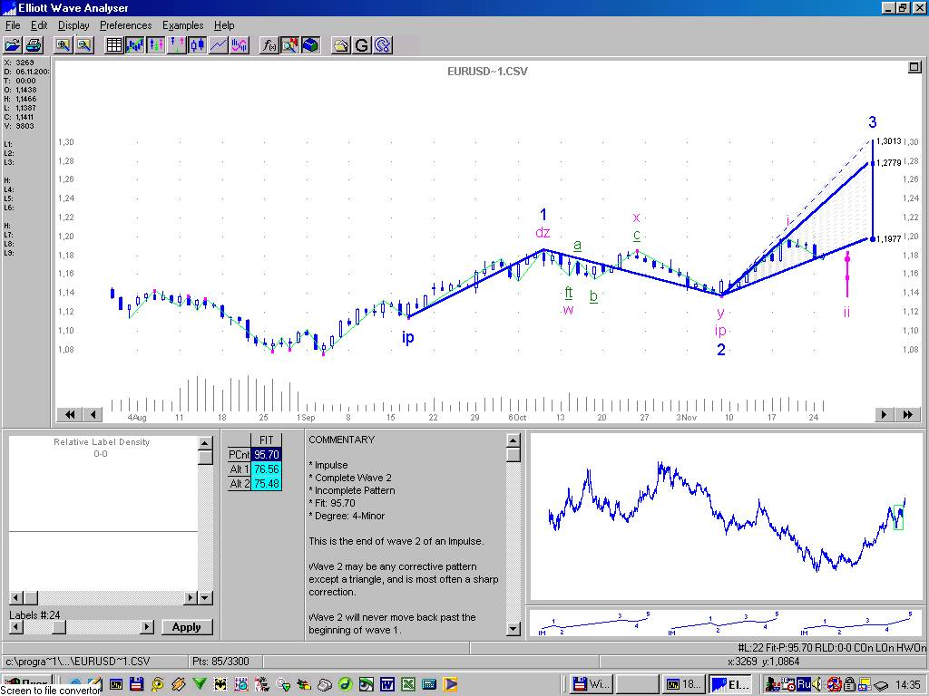
However, and that we do see? We see that EWA not only confirmed direction of further motion, but also it showed the price orientators of profit. Also program very worthily decomposed on Eliot's waves entire graph. All forthcoming motion as on the palm. But you be very attentive with the data input in EWA. It is necessary to introduce data only from the moment of the beginning of the turn STLM, i.e., necessary to program to show correct reference point. Only in this case price orientators EWA will you only gladden. Much whether you did earn, using only EWA? Its use together with [STSF] raises the quality of your forecasts by an order. [STSF] and the zigzags What are zigzags. This is the more simplified and most visual method of mapping Eliot's waves on the graph. I will say even more. This is the best method, which to me is known, until now. We look the figure
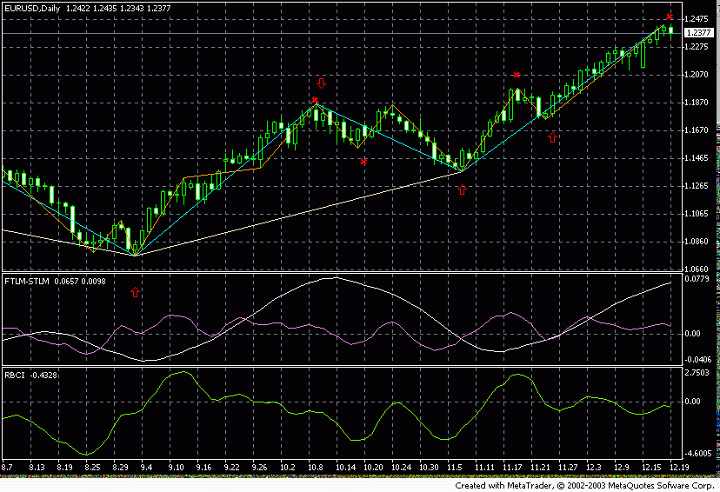
We see three zigzags - white, dark-blue and orange. You already surmised about that. that the zigzags sufficiently accurately show the end of one or the other wave. But if at one point are encountered by 2, and even 3 zigzags!!! Then we see the minimum of [minimorum], as they speak mathematics, or by simple language - minimum point at this point they finished the motion of the wave of three orders. It means the probability of motion in the opposite direction IT IS ENORMOUS! Thus with the entrances it is understandable. We wait connections at one point 2, and better than 3 zigzags - we play against this motion. But which precise output from the position with the aid of the zigzags can be carried out! , in addition connection 2, or 3 zigzags. But we go further and we connect zigzags and [STSF]. Result of work - on the same figure. If at one point refer three zigzags - means this the local minimum. And it will not thus far be the new local minimum with the convergence of three zigzags - we play only upward. It means on the middle of this graph, when STLM was developed downward we DOWNWARD PLAY WILL NOT BE, t to there is no new local minimum, only correction means this altogether, and it is necessary to wait the end of motion downward BY STLM, its minimum, and only after this to be opened upward. I think logic it is intelligible… only further the middle of graph it appears new point in which refer three zigzags. But STLM yet was not developed upward. It means to enter still early. BUT HOW THE WARNING ABOUT THE CHANGE OF TREND GIVE ZIGZAGS!!! Again I will repeat. At first appears the local minimum of three zigzags, then the minimum STLM, then the minimum SATL. But if one is to you to enter - decide themselves. BUT YOU HAVE ALWAYS THE MINIMUM OF 3 WARNINGS ABOUT THE CHANGE OF TREND!!! The packet of indicators “zigzags” you will also obtain. It is necessary file z -trade.tpl to establish into the folder Of metaTrader \ of profiles \ of templates. But the remaining files of archive into the folder Of metaTrader \ of experts \ of indicators \ the order of connection to the graphs is analogous to indicators ATCF. [STSF] and levels [Fibo] I will not stop on what Fibonacci's are levels let us switch over to their use. I used in the stated below figure of Fibonacci arc. But you be very attentive with the data input in EWA. It is necessary to introduce data only from the moment of the beginning of the turn STLM, i.e., necessary to program to show correct reference point. Only in this case price orientators EWA will you only gladden. Much whether you did earn, using only EWA? Its use together with [STSF] raises the quality of your forecasts by an order. [STSF] and the zigzags What are zigzags. This is the more simplified and most visual method of mapping Eliot's waves on the graph. I will say even more. This is the best method, which to me is known, until now. We look the figure
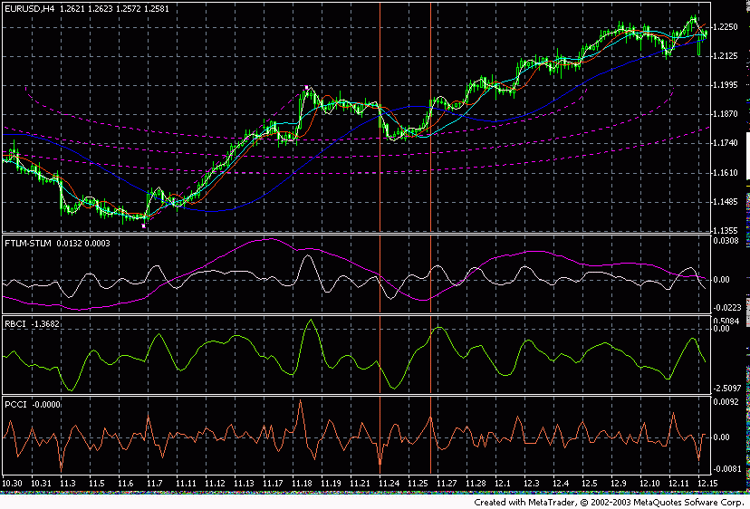
Special attention I want to turn to the region that limited by two vertical lines. This is the region, which indicated the arcs [Fibo] as the most assumed region of correction. We see that the price downy to the first arc and on it stood still. Was developed STLM, and To sATL.[Dazhe] appeared dual divergence (signal L4)!!! And all this at the levels [Fibo]! You can build arcs not only from the local minimums, but also having simply taken as the basis any motion…
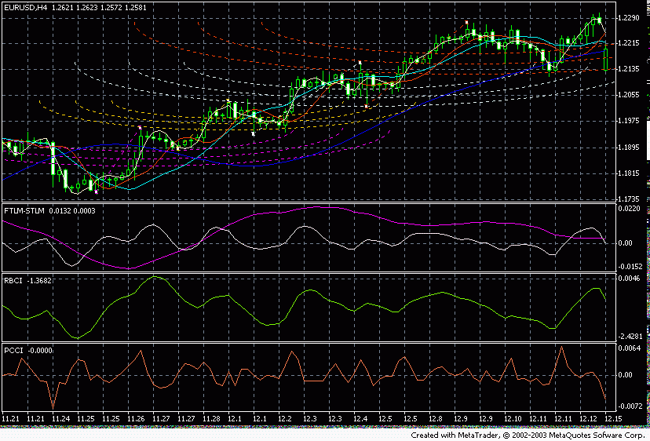
[STSF] and the classical graphic analysis [STSF] certainly helps to make decisions using graphic analysis. Figures given below everything explains. [STSF] and the line of trend.
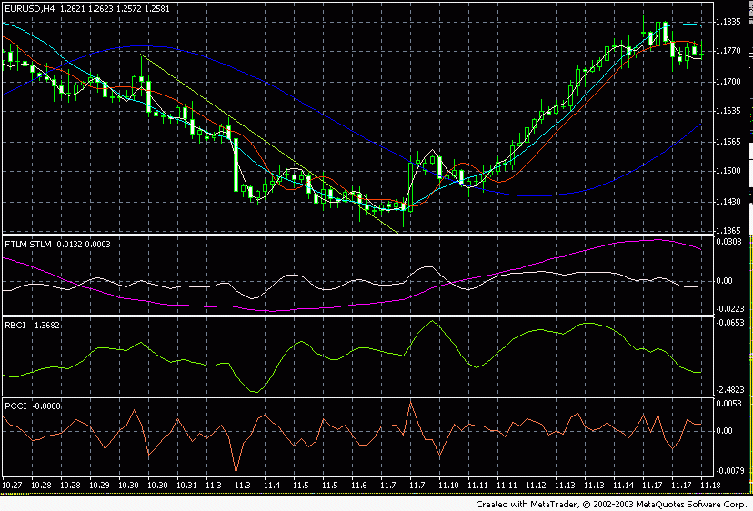
In the figure we see the classical line (light-green), which the price opened. But true this breakthrough upward or not? In this us will help the direction Of sTLM.[My] we see that STLM after penetration by the price of the bringing down line has already been developed upward, it means with the high portion of probability it is possible to speak, that this breakdown true and the prices will go upward. [STSF] and the triangles
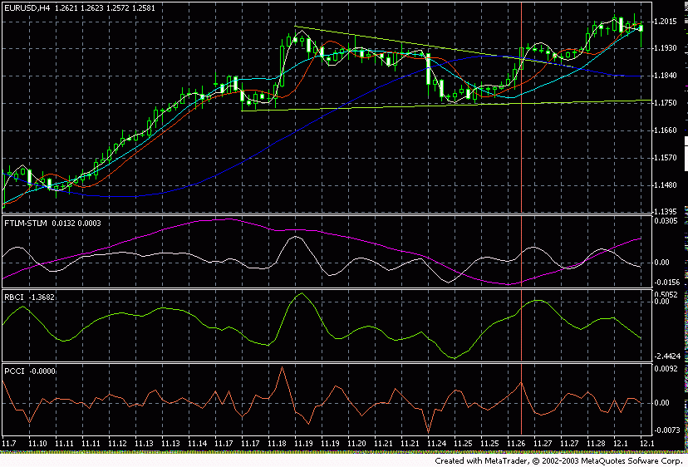
We see triangle. However, where will go price? Where there will be output from the triangle. Everything is very simple. If with the approach to the boundary of triangle FTLM, RBCI they do not show the signs of turn - means expect the penetration of triangle. This is evident from the figure above. [STSF] and the levels of support (resistance)
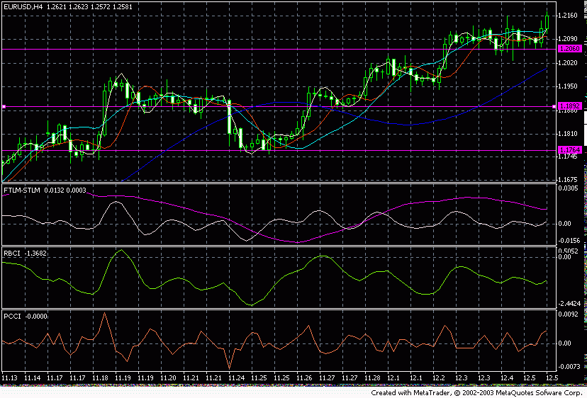
We see that with the reaching with the price of the significant levels of support, FTLM shows its bottom, which means, these levels probits will not be… I do not already recall that these levels are located on the levels [Fibo]. Any other graphic figures are examined analogously. This is understandable. [STSF] and To [ishimoku] I will not stop on how work with the indicator To [ishimoku]. Let us switch over to their joint use. Let us look to the figure.
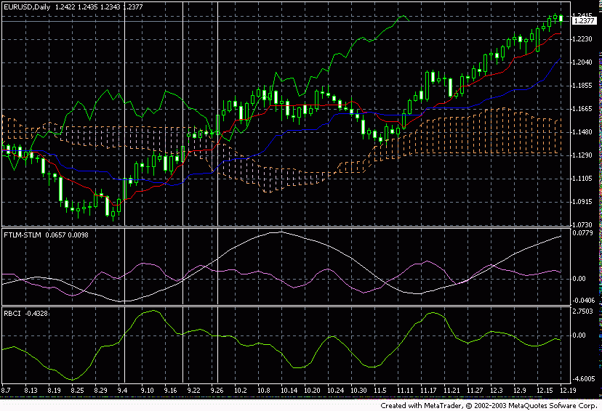
The first moment, at which it would be desirable me to focus attention, this is the moment, when dark-blue and red line [Ishimoku] began it converges to each other with the presence of the minimum STLM we we see to face a good signal of entry at the beginning of tendency. We look further. Price goes in the cloud. I designated this section by two vertical white lines. If does not show intention to be developed after output from this zone STLM - means tendency it will be continued still sufficiently for long. But already if price even did not visit into the cloud, but STLM has already been developed - wait outstanding motion in the direction STLM [STSF] and RVI I will be brief. I use RVI only for determining the signal of divergence with FTLM and RBCI. You will look to the figure.
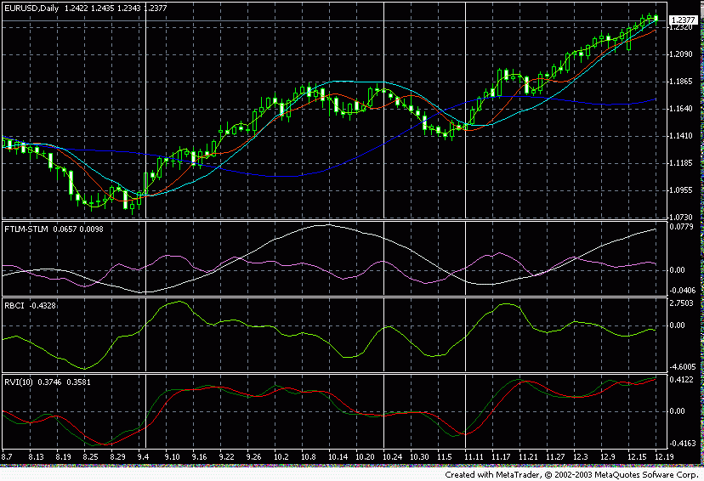
To me to add something. [STSF] and MACD Even MACD is converted into the magician together with [STSF]. We look figure.
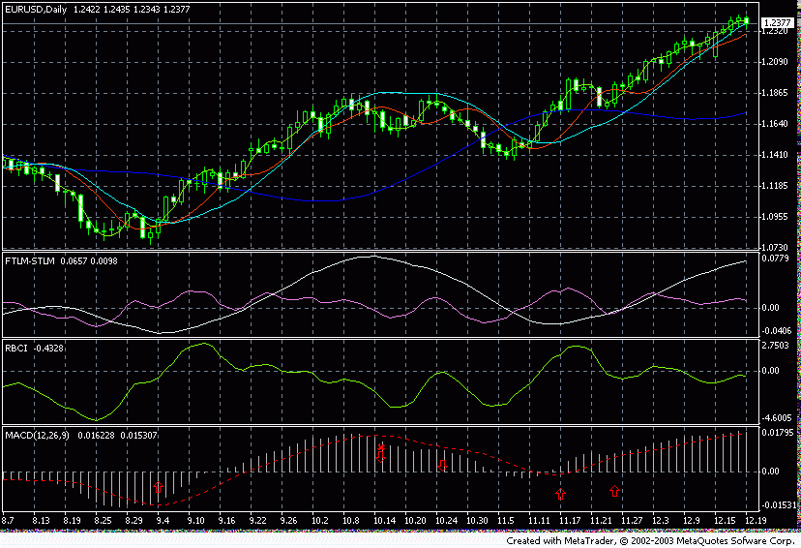
It is simply necessary to be opened upward, when the histogram MACD only of beginning grow already with growing STLM. And vice versa with the discovery of position downward. And to be added, is added with each to the tossing of histogram to the opposite STLM side. [STSF] and the strips Of [bollindzhera] I want to focus attention on one aspect of their application. You will look the figure
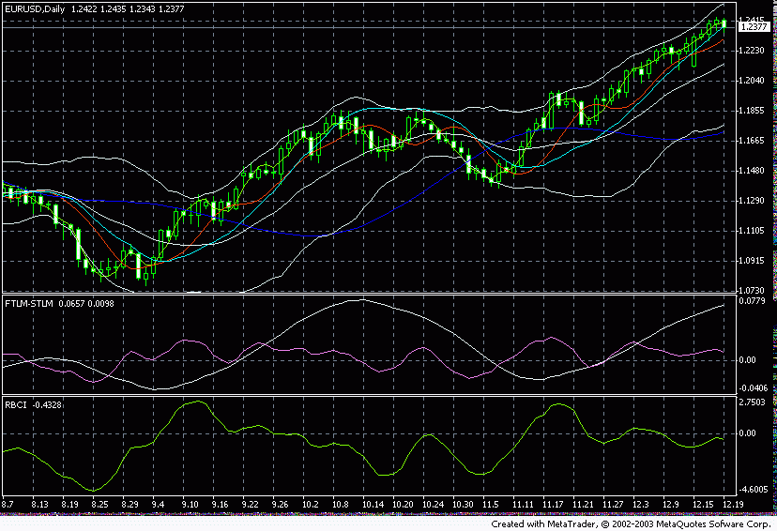
Upward motion below to the left began from the lower strip. They reached the upper. Naturally recoil. Recoil even did not touch the middle strip (about the completion of the afore-mentioned they speak the turn upward BY FTLM and RBCI), which indicates LARGE THE IRROTATIONAL MOTION OF PRICE UPWARD. Let us look now motion from the upper band edge to the lower (middle of graph - correction). We see that after reaching with the price of the bottom of strip the price easily opened center line and it was again fixed upward, repeating entire that outline aboved. Another, not less important aspect of the use of a middle strip - this is the installation on it of stops. This assertion does not need commentaries. Is such my view on the method ATCF. I greatly hope that this method will help you to make reasonable actions on the market. I also please you to satisfy one condition. This work was accomplished by me including for you. You paid for it money. You means greatly you want it to study, [khotyaby] for this reason, returning of money…. Give this method for free no one. Believe, will not be estimated… men it must it reach…. And one more. I constantly improve my method of game. Here you found its backbone. Solid backbone. But I described not all to you. No one of the playing traders WILL DESCRIBE IN ALL. Indeed it itself that must also earn. Therefore do not stop on this. Read literature. You learn.

