Short Entry ....(Trade set-up ) EUR/USD 6/07/06
TAKING A CLOSER LOOK AT THIS TRADE ..........(3 ) CHARTS ATTACHED BELOW
Sell Zone......……........3500
Initial Stop ....................3550 ( 50 pip risk )
1st Target .……………… 3472 2nd Target……..3460
( Remember to Move Protective Stops as the market is moving in your favor ....)
The market sometimes dictates when to get out , by moving up/down your protective stops .
--------------------------------------------------------------------------------------------------------------------------
The Charts by Marketwavez are simply Elliott Wave-counts that are believed to be what a given market is tracing out. Wave counts are highly subjective, and definitely not 100% reliable ...Wave-counts also vary from one person to another who may be analyzing the market and can also vary based on the time frames that are being analyzed .....

THESE CHARTS ARE PUT HERE as a probable Elliott- wave Count - -. A sort of road map of what's going on .
It is not for everyone . –
-Only for those who understand that the true Holy Grail of trading is learning to manage Risk vs Reward .
- - - - - - - -- - - - - - - - - - - - - - - - - - - - - - - - - - - - - - - - - - - - - - - - - - - - - - - - - - - - - - - - - - - - - - - - - - - - - - - - - -- -
TRADE AT YOUR OWN RISK.... The Purpose of these charts is to point out significant highs and lows based on Fibonacci Retracement Lines and Elliott Waves which are highly subjective. This information is for Educational purposes and should
not be considered trading recommendations. All trading decisions are your own sole responsibility.
------------------------------------------------------------- ------------------------------------------------
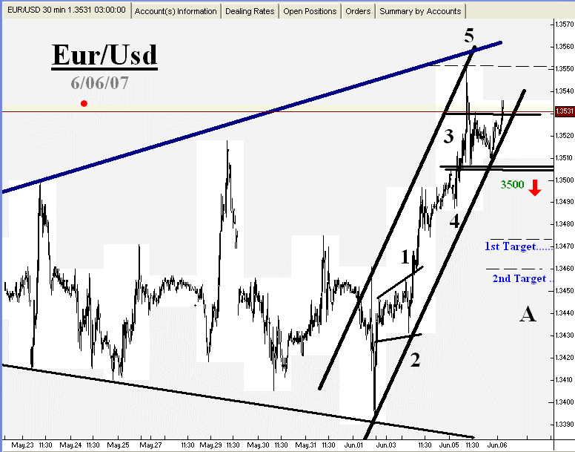
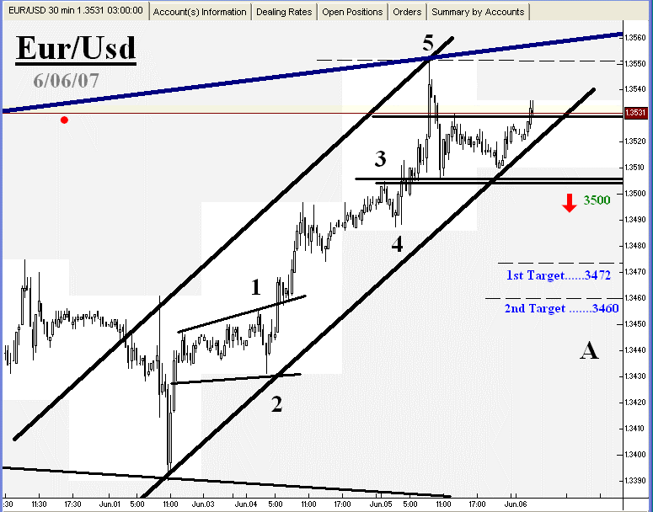
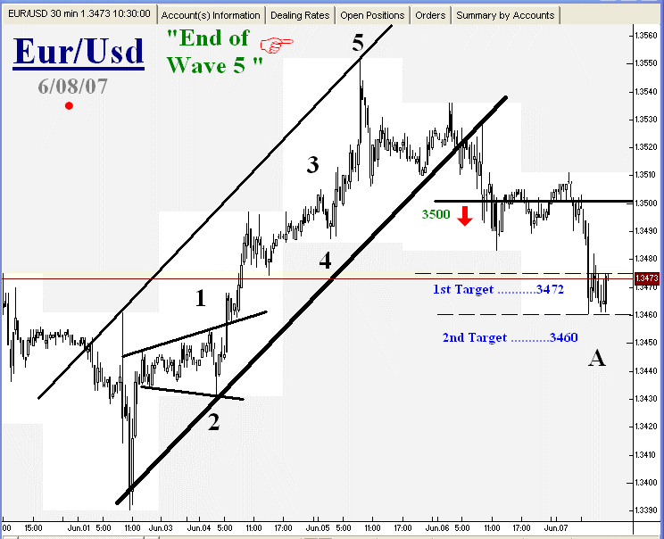
For more information about this trading style ……( See links below )
//////////////////////////////////////////////////////////////////////////////////////////////////////////////

Trading Strategy explained :
Click here : Charts Explained Here www.tinyurl.com/2xwjny

( Listen to this free video )
---------------------------------------------------------------------

----------------------------------------------------------------------
Best Elliott Wave software for generating automatic trade-setups :
Click here
--------------------------------------------------------------------------------------------------
//////////////////////////////////////////////////////////////////////////////////////////////////////////////

