SKYDART SYSTEM

1.General method for opening a position

- Watch the bar chart (candle chart 30M)

(b) When the signal approaches, switch to 15M and carefully open the position
(c) Next return to 30M

The „buy” signal

FX Sniper’s lines cross
CCI raises above zero and the dot on line LSMA is green
Waddah Attar – the green line of the histogram crosses the yellow signal line from below, the yellow line is above the blue broken line; even better if the yellow line is rising.

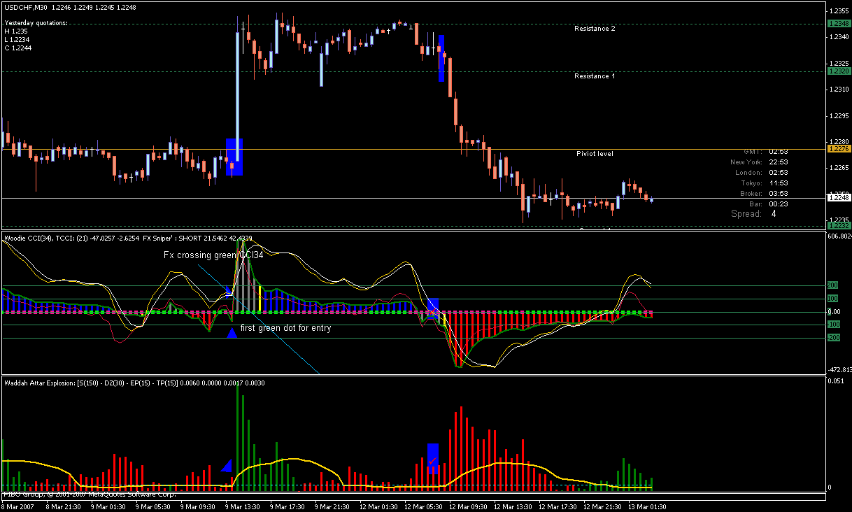

Closing a position

FX Sniper’s lines cross and generate a „sell” signal, or both FX Sniper’s lines cross CCI-34.
The grren line of the histogram hids underneath the yellow signal line

The „sell” signal

everything is reversed compared to the „buy” signal...
BUT!!!
Waddah Attar – the red line of the histogram crosses the yellow signal line, the yellow line is above the blue broken line; even better if the yellow line is rising

Reversal or aggressive buy/sell signal

The signal occurs when after a significant activity there is a sudden reversal
FX Sniper’s lines cross each other, or both lines cross CCI34 without crossing each other and generate a „buy” signal
The green or red histogram Waddah Attar HIDES BENEATH the gold signal line – observe the first bar (candle) at which the histogram will hide beneath the signal line and change colour.
The colour of LSMA dot is consistent with the position being opened (green for long, red for short).

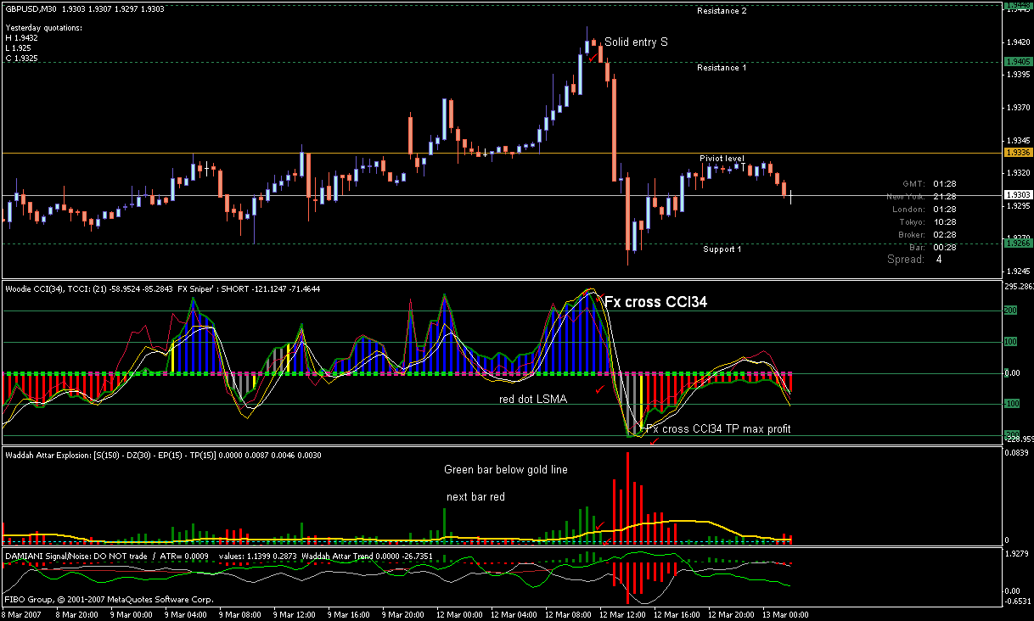

General remarks

There is no unequivocal answer to questions like „how to position the stop loss ”, „how to position the take profit ”, etc. These things depend on individual risk acceptance thresholds and individual greed.

