Brief of request for custom indicators -
1. MT4 delta volume indicator
2. MT4 delta volume correlation indicator
Both indicators should show print data as per the different time frames of the respective candles i.e. from 1 min to daily etc.
In detail -
1. MT4 delta volume indicator (Indicator 1).
- Should show the difference between number of upticks and downticks for a given candle stick i.e. it should only show the difference (delta). To be more specific number of upticks and downticks do not need to be shown.
-Since it is a ‘delta’ each bar will only contain one form of data i.e. either up or down.
-information will be displayed in an indicator window as per the currency pair on the chart.
- The delta value should be displayed as a histogram. User can choose histogram thickness.
-The user should be able to specify any colour of their choice for the delta uptick and down tick. To be more specific - the delta uptick can be ‘green’ in colour and the delta down tick can be ‘red’ in colour. i.e. any custom colour can be chosen by the user..
In the indicator properties box a delta uptick should be associated with a specific currency and colour. Correspondingly a delta downtick should be associated with a different currency pair and colour.
The colour and currency pair is customisable dependent on user specification.
Example schematic diagram (figure 1) for delta value indicator on a 1 min EURUSD chart -
Where
delta uptick = EUR positive = Red colour
delta down tick = USD positive = green colour
Figure 1 -
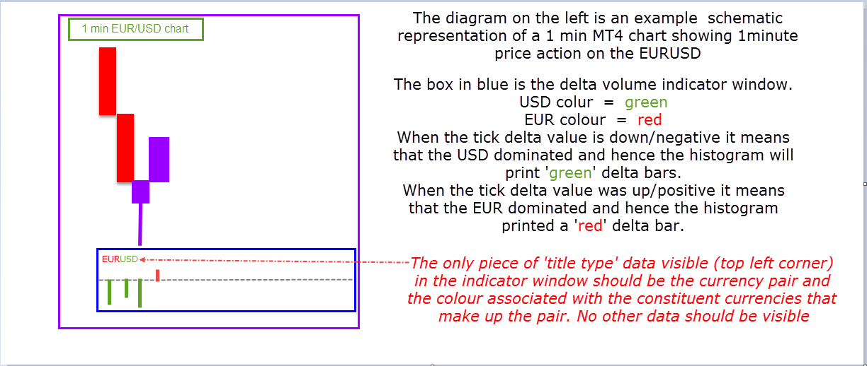
2. MT4 delta volume correlation indicator (indicator 2) -
- This indicator data will be displayed in a different window than from indicator 1.
- This indicator will use data pulled from different charts that have indicator 1 on them.
- This indicator will show/print data when there is a similar tick delta move between 2 or more ‘specified ‘currency pairs. Hence the name ‘delta correlation indicator’.
The correlated currency pairs will need to be specified by the ‘user’.
-The indicator will only print data when 2 or more (this depends on the input of the user) of the specified/ correlated currency pairs show the same value.
-The indicator data will show currency strength or weakness i.e. with respect to the correlated/specified currency pairs
- The printed data type can be either ‘green’ (positive for the respective currency) or ‘red’ (negative for the respective currency). The colour i.e. either of the 2 can be nominated by the user.
- While loading the indicator the user will need to specify in the indicator properties window –
- How many currencies will the indicator analyse.
- How many currency pairs ( correlated/specified currency pairs) will be there for each currency being analysed.
Example schematic diagram (figure 2) -
Since this indicator needs to pull delta values from indicator 1. Only the indicator 1 windows will be shown in the below schematic diagram.
This is because the information in indicator 1 is independent of price information on the respective charts. In reality there needs to be indicator 1 loaded on each of the charts.
Colours for different currencies used in indicator 1 –
EUR = purple
GBP = blue
USD = purple
AUD = brown
Different currencies for indicator 2 and their respective specified/nominated currency pairs-
EUR – EURUSD,EURAUD
GBP - GBPUSD,GBPAUD
USD – EURUSD, GBPUSD,AUDUSD
AUD – EURAUD, GBPAUD,AUDUSD
Hence a total of 5 different charts needs to be open and have indicator 1 loaded onto them.
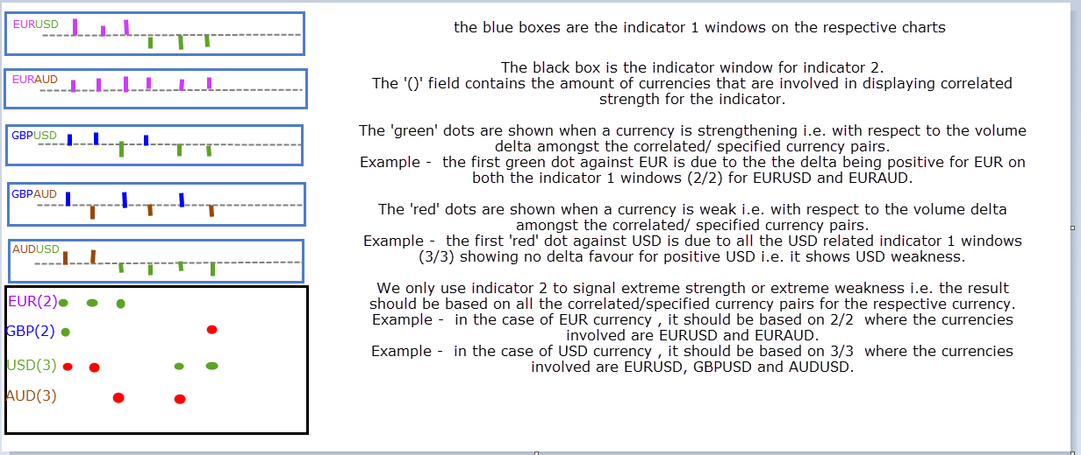
- The results of indicator window are specifically based on the input provided in the respective indicator window. i.e. with respect to the currency being analysed and the nominated/specified currency pairs.
Example scenario 1 -
EUR – EURUSD, EURAUD
USD – EURUSD,AUDUSD
AUD – EURAUD, AUDUSD
Example scenario 2 (Same as in figure 2)-
EUR – EURUSD, EURAUD
GBP – GBPUSD,GBPAUD
USD – EURUSD,GBPUSD, AUDUSD
AUD – EURAUD,GBPAUD,AUDUSD

