Schematic representation for indicator #3 -

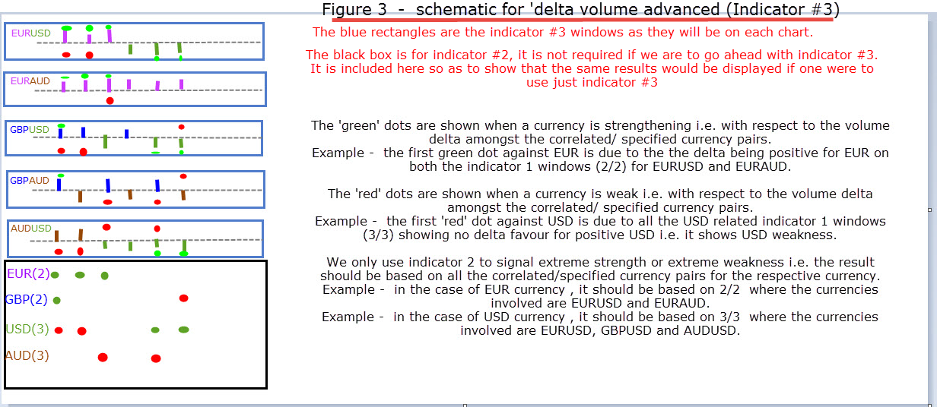
Note the clear relatively big green and red dots in the indicator #3 windows showing strength and weakness
The only additional features per indicator window in this case would be -
- An option to specify the strength and weakness colour.
- An option whether to show
a. Only strength
b.Only weakness
c. Both ( by default)
d. Turn the correlated strength /weakness section completely off
Predominantly all else will remain the same except for slight modifications, please go through the below as I believe it will make things more clear and perhaps you can also provide some suggestions as per your discretion.
- Should show the difference between number of upticks and downticks for a given candle stick i.e. it(histogram) should only show the difference (delta). To be more specific number of upticks and downticks do not need to be shown.
-Since it is a ‘delta’ each bar will only contain one form of data i.e. either up or down. (alongside strength and weakness as it occurs)
-Histogram information will be displayed in an indicator window as per the currency pair on the chart.
- The delta value should be displayed as a histogram. User can choose histogram thickness.
-The user should be able to specify any colour of their choice for the delta uptick and down tick. To be more specific - the delta uptick can be ‘green’ in colour and the delta down tick can be ‘red’ in colour. i.e. any custom colour can be chosen by the user..
In the indicator properties box a delta uptick should be associated with a specific currency and colour. Correspondingly a delta downtick should be associated with a different currency pair and colour.
The colour and currency pair is customisable dependent on user specification.

- This indicator will require Indicator #3 to be loaded on all the charts that are used in the analysis of each currency.
- The green and red coloured ( colour can be changed based on user requirement) clear big dots ( relatively) will be visible when extreme strength or weakness occurs amongst the currency pairs being analysed.
i.e. when 2 or more (this depends on the input of the user) of the specified/ correlated currency pairs show the same value.
- While loading the indicator #3 the user will need to specify in the indicator properties window –
- How many currency pairs ( correlated/specified currency pairs) will be there for each currency being analysed.
- And enter the currency pairs being analysed preferably separated by a coma -
Example in the case of Indicator #3 being loaded on the EURUSD chart -
Example EUR – EURUSD, EURAUD
USD – EURAUD, GBPAUD,AUDUSD
Note - It is Currency and Currency pairs i.e. both are different
Colours for different currencies used in indicator #3 in figure 3 –
EUR = purple
GBP = blue
USD = Green
AUD = brown
Different currencies for indicator #3 and their respective specified/nominated currency pairs-
EUR – EURUSD,EURAUD
GBP - GBPUSD,GBPAUD
USD – EURUSD, GBPUSD,AUDUSD
AUD – EURAUD, GBPAUD,AUDUSD
Hence a total of 5 different charts needs to be open and have indicator #3 loaded onto them.
- The results of indicator window are specifically based on the input provided in the respective indicator window. i.e. with respect to the currency being analysed and the nominated/specified currency pairs.
Example scenario 1 -
EUR – EURUSD, EURAUD
USD – EURUSD,AUDUSD
AUD – EURAUD, AUDUSD
Example scenario 2 (Same as in figure 2)-
EUR – EURUSD, EURAUD
GBP – GBPUSD,GBPAUD
USD – EURUSD,GBPUSD, AUDUSD
AUD – EURAUD,GBPAUD,AUDUSD

