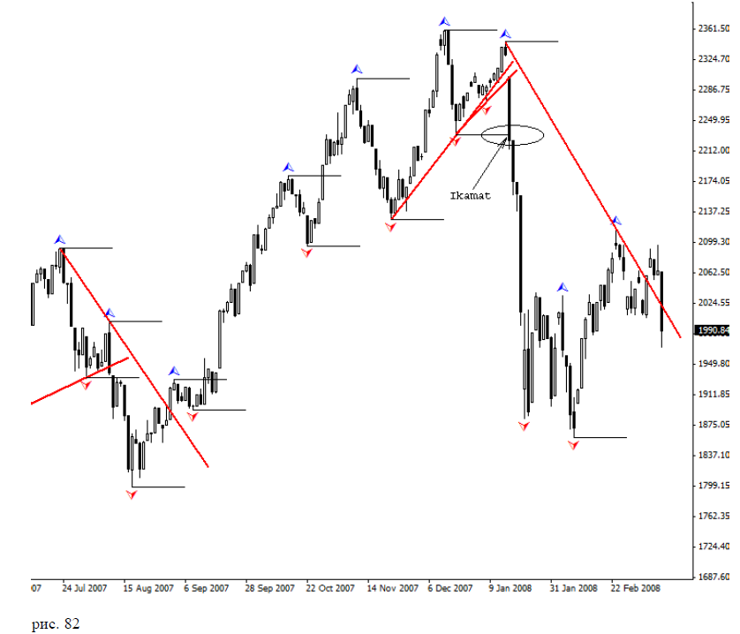
Daily chart of the RTS with two changes of trends. Select the last
trend, since it is a change of trend in the down trend, ie against the main
movement in the upper times.
At first glance, this is a clear instrument overheating. On both charts older times
strictly noticeable upward trend, and no signs of a reversal. For us it is important
one - pre-calculate start changing trends and place an order strictly on our TS. now
Let's look at the intraday charts:
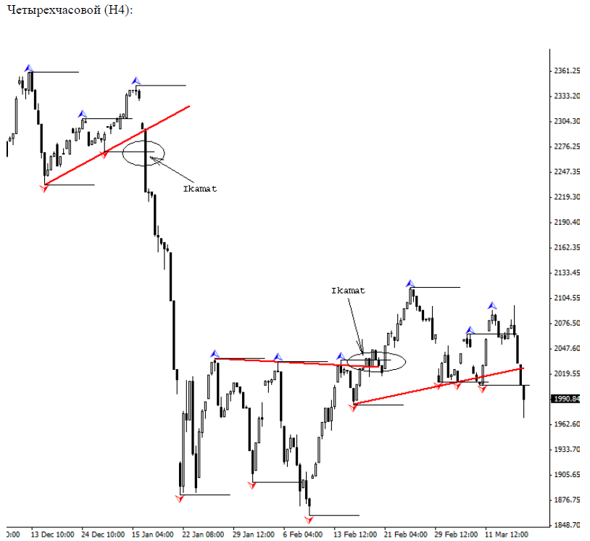
Entering the market for ikamat on H4 at almost the same level as that on the daily chart.
This indicates a strong level that we expect from the bottom by changing trends. Enter the market
for sale at a price of 2213, the minimum price of a daily candle, break level
"Yamma", ie immediately after the takbir. Next we see that the price below 1900 show the market
very good level to enter, and with this level began rolling back the first wave of rak'ahs. on H4
noticeable change in the level of the trend, but on the daily chart - it's different.
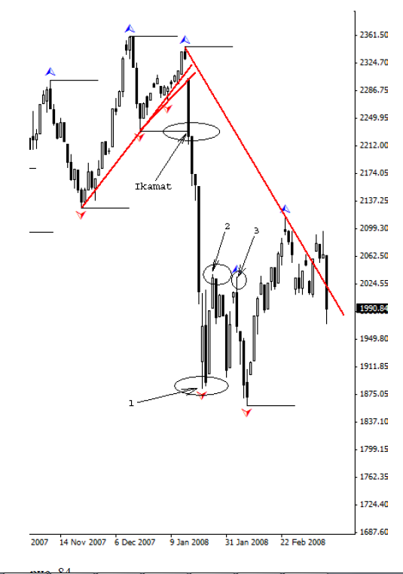
Takbeer a mark one did not "yammoy" because the candle under the mark 2 was
unable to become Takbeer, and the subsequent "Takbeer" under the mark was below its 3
maximum, thus demonstrating the inability to generate levels of "yamma" and "Kimmie", as
gave me an excuse to ignore these levels to identify them as "yamma" and "Kimmy."
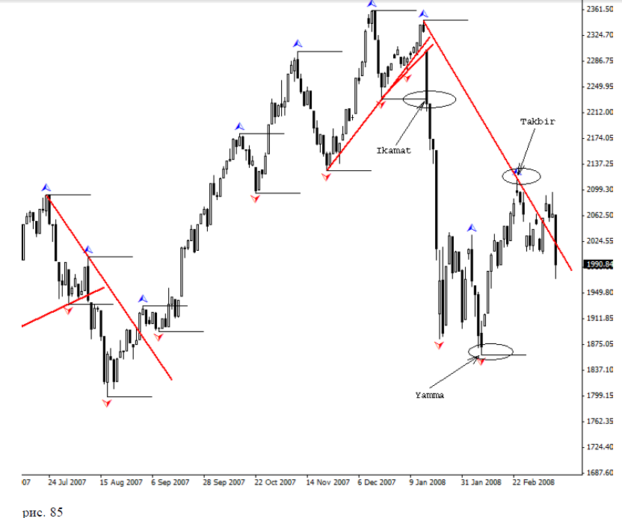
"Yammoy" was the next Takbeer, which became a point of rollback one rak'ahs wave. further
Takbeer and formed a new potential "Kimmy." Through it (Takbeer) we held the line
resistance through which sounded Azan. Will continue ikamat - time will tell.
After all, now owned and is subject only to God, His praise and glory!
To date, still relevant downward trend, so the end,
likely to be described in the next book on the subject, if it is the will of Allah.
Now let's get the latest example of the commodity market. As you guessed, we
will assess the oil futures.
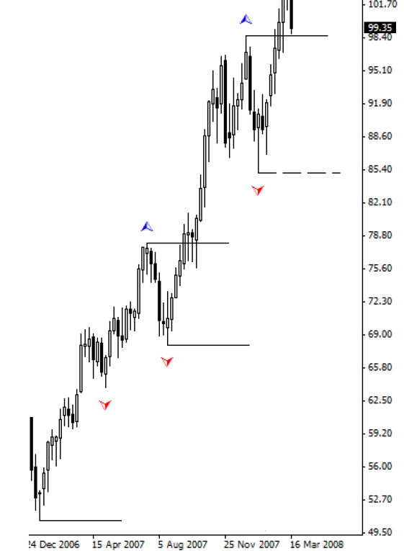
Week as the month and shows us strict uptrend. I would like to say that I
introduced to simplify the dotted lines mark the last unconfirmed level.
Unconfirmed are the latest takbir. As soon as the next
opposite Takbeer, he automatically becomes a level of "Kimmie" or "yamma."
Both time (month and week) show us the uptrend, but with the recent developments
Sliding scheduled yet wave. Let us now look at the daily chart.
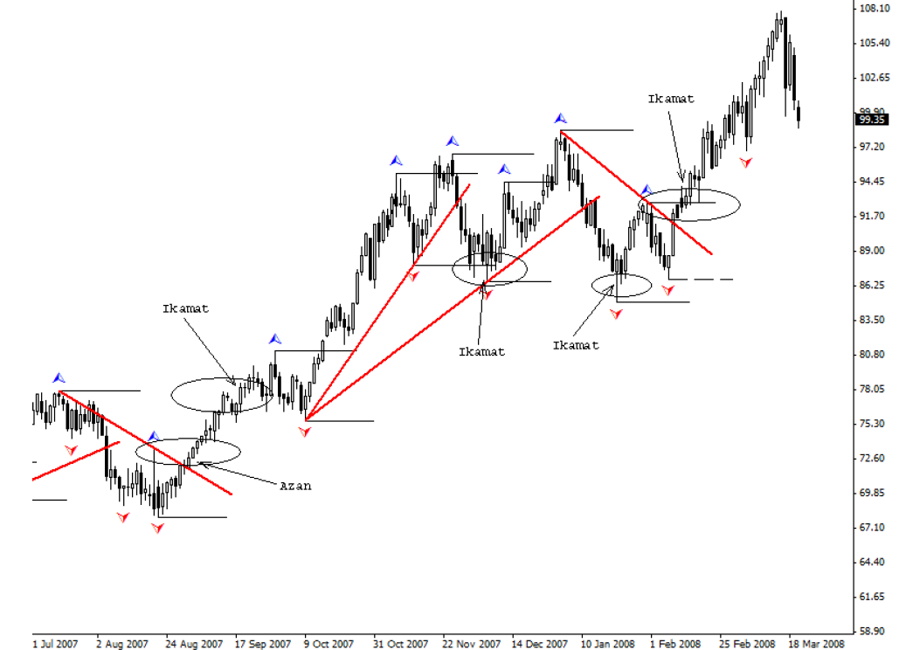
Well, how long will take for analysis? I propose to take the first adhan and ikamat. this
time is also interesting in that it Takbeer, which served as a point through which we had
resistance line, could not be the level of "Kimmie" due to the fact that at least this
Candles were lower than the last lower Takbeer. This adds fuel to the fire of our
technical analysis, and gives even more uncertainty at the time. Let's try
unravel this puzzle and mystery, in which lies the Grail.
As you may have read earlier on oil futures contracts, our TC
We found a pattern, repetition. Often or almost always, read the Adhan, the price
comes to ikamat. Also in this case, it happened, both in agreement, and it is in principle
gives us an extra dime to our bottomless pocket. Is this bad? I think it is
"Good."
Still, look for one more item, the inside of the case.
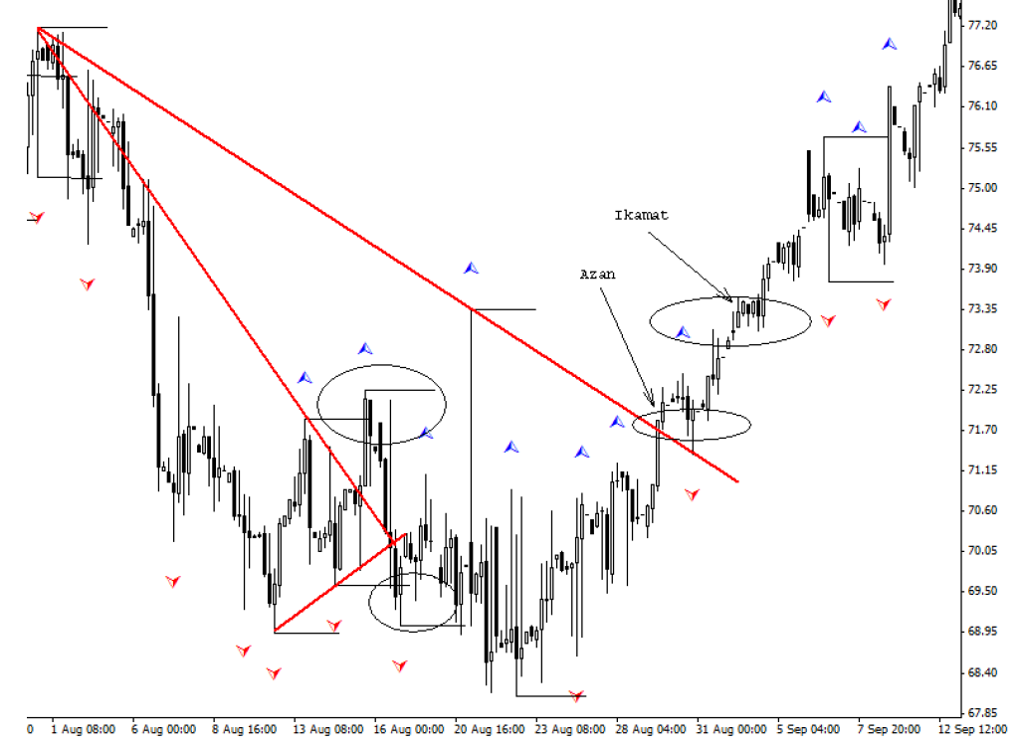

At the four-hour chart shows a strong volatility that rocked the waves in
apart and gives us the ability to accurately connect adjacent levels of the past,
but I think, for us is not a hindrance. We provide the latest and the highest levels
seeing each other directly, without intermediaries.
Why are we still decide to open a buy order? First, at both senior
times - an uptrend. Second, on the weekly chart candle closed at the time
signal, marking a possible end of the recoil of the wave:
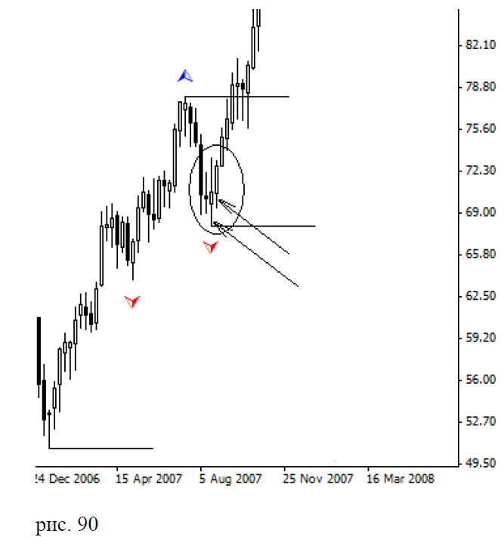

In Fig. 90 arrows indicate the two weekly candles, showing us the signal to
purchase. Third, according to the logic of things, if there are no signs and clues in the opposite direction,
best - to continue their journey. What we have done. Enter the market at a price of 73.52. this is higher
maximum candle, break ikamat on H4, exactly 1 cent. The stop is at last is
"Yamma", the daily chart: 68.10. On H4 and Daily price stop the same, which gives us another
greater confidence that the price there just will not come, and if it comes, it will not return.
Use to enter the market internal time we opened the order for ten days before and 4
dollar lower. Exactly 3 months we ikamat comes new, third on the pullback rak'ahs
Daytime, where we are closing your order at the price of 87.55, earning 19.45 excluding this
Commission.
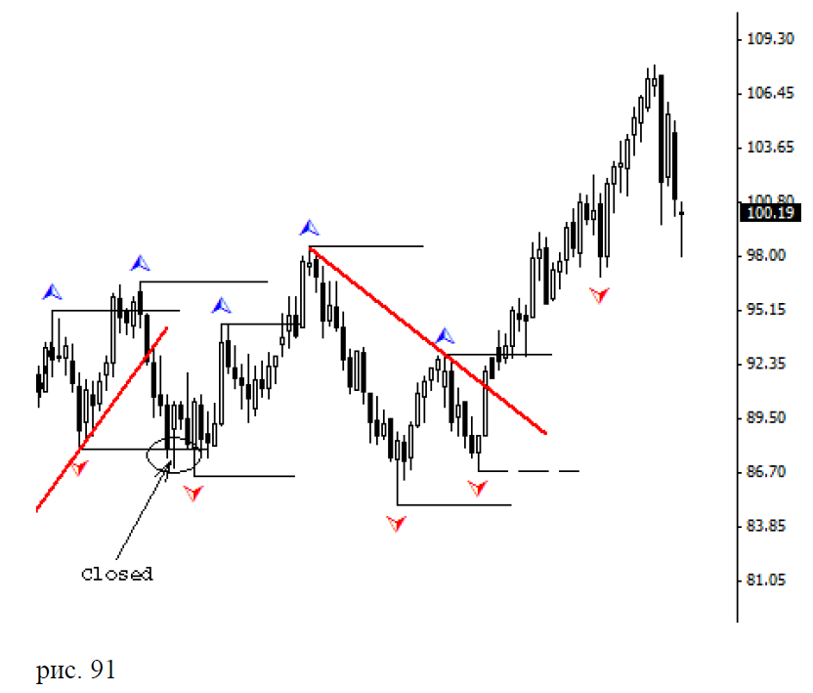
In Fig. 91 shows a point out of the market and the closure order.
Well, that's all. I very much hope that my book will give us something to help you in achieving
knowledge. Though she is not as bulk as opposed to others, but I tried to tell her
laws established by Allah Almighty.
In addition I would like to give a set of rules to one of my old friend, who after
some time in Forex trading, as she said, "His blood wrote the rules." On
her request, quote all the same.
1. You always know why the lost money.
2. Depot always go to zero.
3. You're always sure that this time everything will be OK.
4. Once the order is triggered, the price goes directly to the other side.
5. Once triggered stop, the price is right where necessary.
6. At the depot for a week doing x100.
7. Find the Grail, "merge" and then you find, and then "merge", and so the circle.
8. We all know how to make money in the Forex market, and we can talk about it in detail.
9. The rule number 8 that 100 out of 100 - "merge".
10. Minus 100 points - is the norm, plus 30 points - a lot of money, and they urgently need to pick up.
11. Everybody knows about the MM and TC, how about traffic (traffic rules), and 60 km / h travel only
"Woodpecker."
12. After the "plum" going 5 km / h
13. Go with the trend, do not break the MM and TC, put the foot ... it is not smoke, not the mother, do not drink ...
right, but not feasible.
14. Books about Forex, as fruits of plastic - pretty but inedible.
15. You are not able to earn on Forex - teach others (write the book).
16. Experience in Forex - as things in the pantry, use - zero, but always believe that useful.
17. Forex - is a sure way to purchase the magazine "Working for you."
18. The market may be "illogical" for much longer than you - solvent.
I hope my book will help her a new perspective on the market.

Many of you in the process of reading the book, probably, there was a question about the importance of the takbir
and levels. I want to note that the level of, as you know, is formed thanks to the takbir, and
wave - thanks levels. It turns out that Takbeer - half the level, and the level - half
wave. Therefore, in the graph layouts adhere to this concept. If there is no level
Use Takbeer. If there are no waves - look at levels.
One more thing, I'm sure, was not quite as clear for you. This difference
between Takbir and levels "Kimmie" and "yamma." So what did the difference for
our analysis between the Takbir and the levels that are formed due to this Takbeer?
Takbeer - is a landmark, and the levels - goals. When you get the Takbeer, you will first
draw the line from the last native to the Takbir, noting the resistance or support. He
is involved in the process, had not set level, ie we focus on it to replace
process when it punched. He is to us a messenger who brings the good or
bad news. The levels are the same goals, from which and to which we hold on his way.
Reached or passed - is another question. Most importantly, they are the light at the end of the tunnel,
that we go, not knowing what will happen when we get out of it, although I suspect that all-
It is the same in the end. Which - we learn at the output. At the closing of our warrants.
What is iman? Iman - is faith. Faith in God and all that he has created around you.
Faith in all its laws established for us. After all, we can choose what we believe. We
are always looking for better, to feel comfortable. Such is the nature of man. After all,
almost everyone wants the best for themselves, even against their faith. We always believe that all
will be good. Even pessimists at heart always hope for a good outcome, rather than on
bad. Thinking that everything is bad and will get worse, they hope, even in this find a
sedation.
Iman also has its weaknesses and strengths. Once upon a time it is very strong when-
is very weak. Between them there are ups and downs. For the most part, as well as in the market,
fall faster than the rise. Fall is always easier than the climb. Special efforts
not. Summed up, stepped - and falling. The most difficult thing in this situation - to stop, and,
stopping to try to understand the cause of the fall and to find its footing.
All of this is not only our faith. This can be attributed to management
capital and generally to something else, that is amenable to technical analysis.
In conclusion, I would also like to thank my friend Damir for assistance in drafting
evidence of verses from the Koran.
It's all about what I wanted to tell you about. I hope my book will help you a little bit
understand how the market works and how it is formed on the move. I would like to reiterate
interrelation of all things in our world. If you do not understand something in a situation,
maybe you will find an explanation of the situation in other circumstances. Always look for
root, and from the middle develop logic. I want to wish you good iman and large
patience. Endure, for God - with the patient:
153. O you who believe! Seek help in patience and prayer. Allah - with
patient. (Surah "The Cow")
46. Obey Allah and His Messenger and do not dispute, and not something you will fall and lose the spirit forces.
Be patient, for Allah - with the patient. (Qur'an, "Extraction")

