The AAA-Chart
AKA
The Triple –A- Chart

Here is the AAA-Chart setup
This setup is recommended for 4hr trading but can be used for 1hr-Daily charts.
The Triple A chart setup is a continuation of the X-chart. Except with this chart you focus on the 55 and 45 levels of the RSI to enter your trades.

RULES FOR TRADING
BUY SIGNAL
wait for the RSI to cross the 55 level UP
SELL SIGNAL
wait for the RSI to cross the 45 level DOWN
SLTP Expert
Make sure you put the SLTP file in the expert folder. Not the indicator folder.
This will let you move around your take profit and stop loss lines just by double clicking on the line and then moving the line by click and dragging it to the location you want to set your take profit and stop loss and then double clicking on the line again to set.
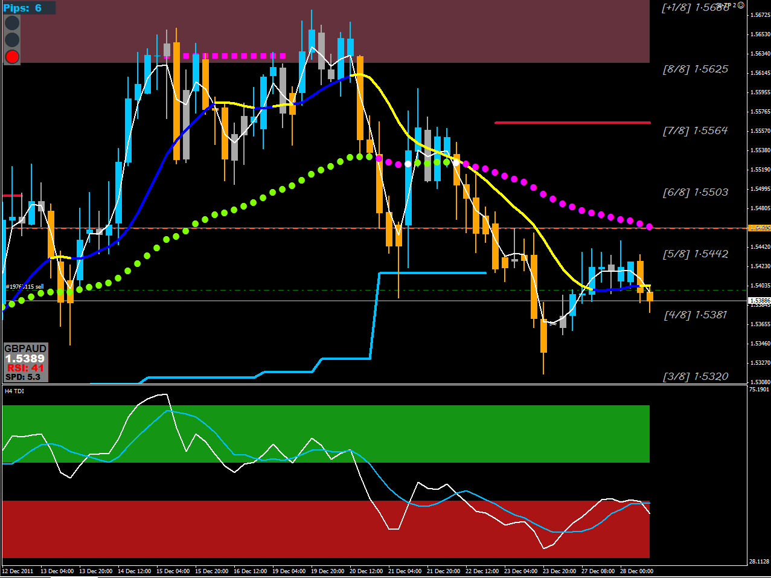 cross the 45 level DOWN

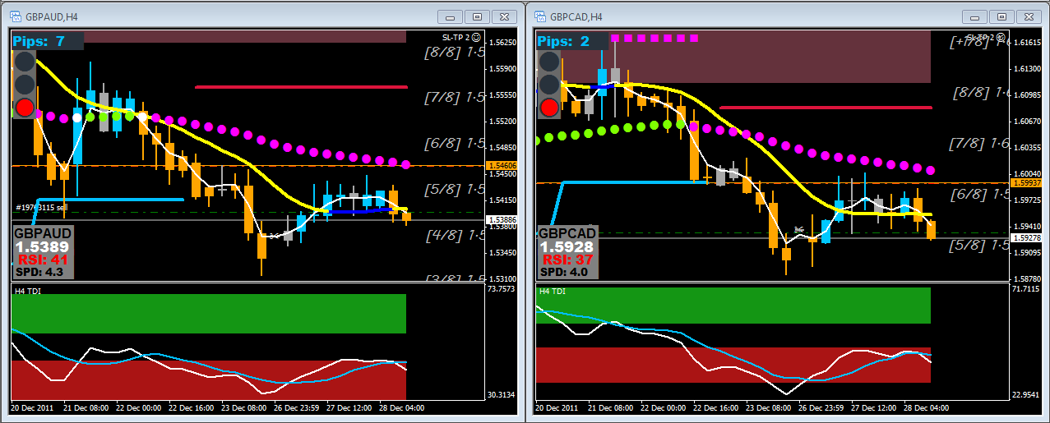
Take a BUY when RSI is greater than 55 and SELL when less than 45
Here is Both GBPAUD & GBPCAD on test.

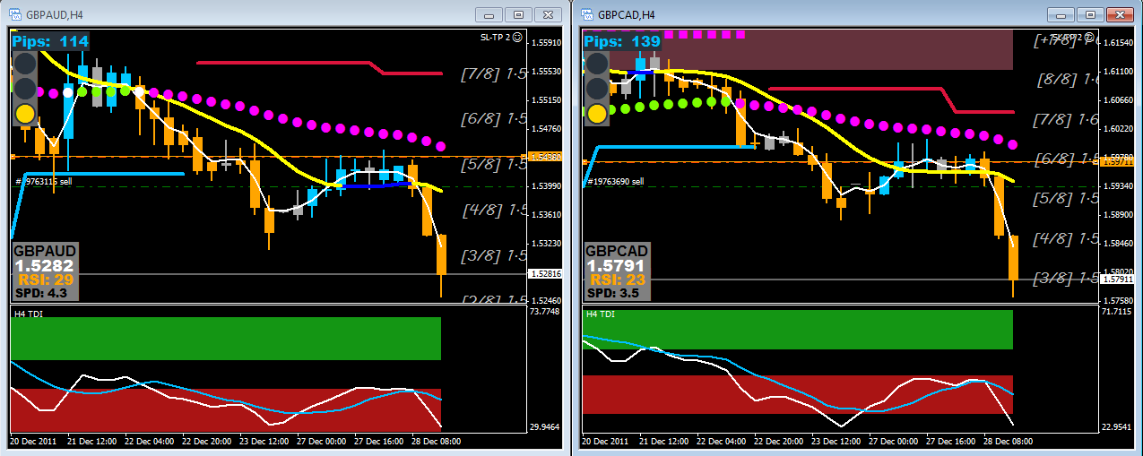

This strategy isn’t new, it’s pretty a simple trading strategy. And very effective.
Just simple take your trades when the white line in the subwindow crosses below or above the blue line into or inside the red or green colored back ground area in the same subwindow.
You also want the white line on the main chart to cross up over or down under the colored Moving Average.
You want the colored Moving Average to change color to indicate the beginning of the trend. Yellow line is down trend and blue line is up trend.
You want to trade with the bigger trend so check the next bigger time frame for direction reference.
You want to trade with the bigger trend so trade in the direction of the slope BB’s. If you have green BB’s or a big Green Dot then use this as a reference to look to take buy trades. If you have a magenta BB then you want to look to take sell trades.
Make sure the white signal line MA has crossed completely across the colored BB and the BB has changed color before you have considered a change of trend direction.
Only take trades when the white line in the sub window has crossed into the colored background of the subwindow. This is to insure you won’t get thrown off with price dancing around the 50 level of the TDI.

Here is Cable 1Hr this time just as the RSI goes below 45...

