[**Drive MT4 Indicator – Drive Your Trades In Right Direction**](http://www.forexmetatraderindicators.com/drive-mt4-indicator-drive-your-trades-in-right-direction/) **D.English**

[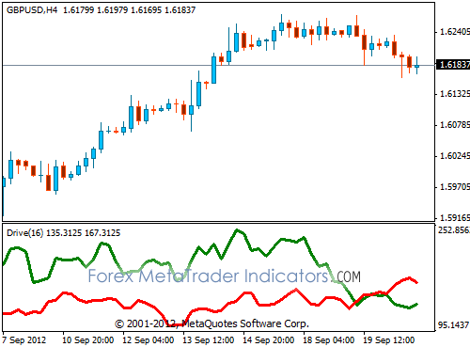](http://www.forexmetatraderindicators.com/wp-content/uploads/2012/09/drive-mt4-drive-your-positions.gif)

I use this indicator every day. It’s the best for trend reversal signals. When red and green lines are really close or cross each other it’s obvious that trend is going to change very soon.

For better understanding, if green line is up it’s up trend, if red line is up it’s down trend. This indicator is originally designed for comparison between total up & down movement and of course it identifies trend.

If you use any strategy and that strategy suggest you to trade, use this indicator to confirm it.

[**Trading With Fisher Indicator**](http://www.forexmetatraderindicators.com/trading-with-fisher-indicator/)

[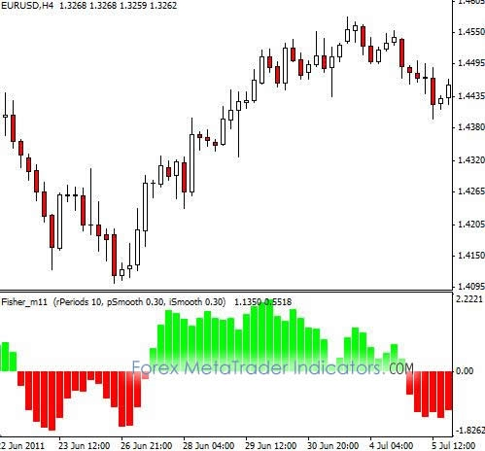](http://www.forexmetatraderindicators.com/wp-content/uploads/2012/05/Trading-With-Fisher-Indicator.jpg)

If you are a forex trader looking for a strong leading oscillator to detect the trend direction and current strength of the trend, you should definitely use Fisher indicator. Fisher indicator is a simple follow histogram. Fisher applies advanced math equations to identify the connection between the current value and minimum/maximum prices.

[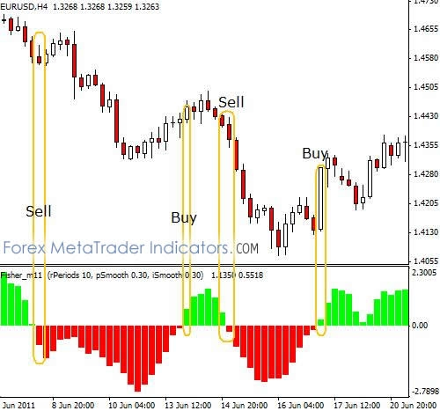](http://www.forexmetatraderindicators.com/wp-content/uploads/2012/05/Fisher-Indicator-Buy-Sell-Signals.jpg)

The green bars indicate that the trend is bullish and the red bars indicate that the trend is bearish.

**How to Trade With Fisher Indicator**

**Buy Signal:** When the bar color changes from red to green

**Sell Signal:** When the bar color changes from green to red

[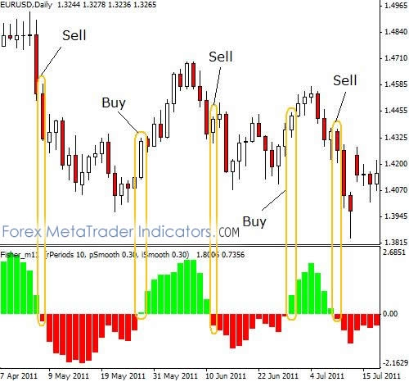](http://www.forexmetatraderindicators.com/wp-content/uploads/2012/05/Fisher-Indicator-Example.jpg)