100 pips trailing strategy
by “cherpu”

Timeframe: D1 (Daily)
Check all available pairs like USD/GBP etc. for the BUY/SELL Signal Arrow.
In daily timeframe every candle describes one day.
The arrow should be formed and should be there at the end of a day. You should not trade on that day.
You should trade the next day only if the signal is still there, we enter a trade in the direction of the arrow. You should enter the trade at the start of the new candle.
As per this system you should only enter one trade per currency pair that too if all the above conditions are fulfilled.
You should not enter a trade if you do not see the BUY/SELL Signal arrow, wait for arrow to form on another day or look at other currency pairs for the signal arrow.

Take Profit: 100 pips
Trailing Stop: 25 Pips
Stop Loss: Optional -> if set low of the signal arrow spike

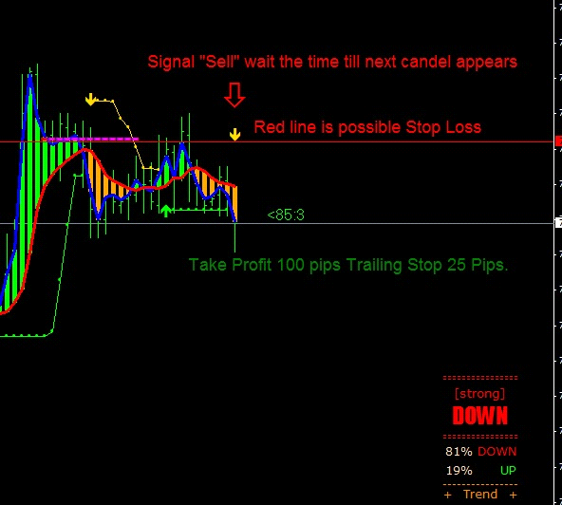

Attention!
trailingstop only works if the trade goes minimum 25pips in profit, trailingstops are controlled by Metatrader, not your Broker!
If Metatrader is Shutdown, only a conservative Stoploss will work.
The system seems very profitable but no system is “perfekt” be careful and follow the rules.

manual by Visitor
Dokument is free to edit, just add strategies or ideas.

